

Riverview Football Program - Match reports Saturday 31st, May

YEAR 7 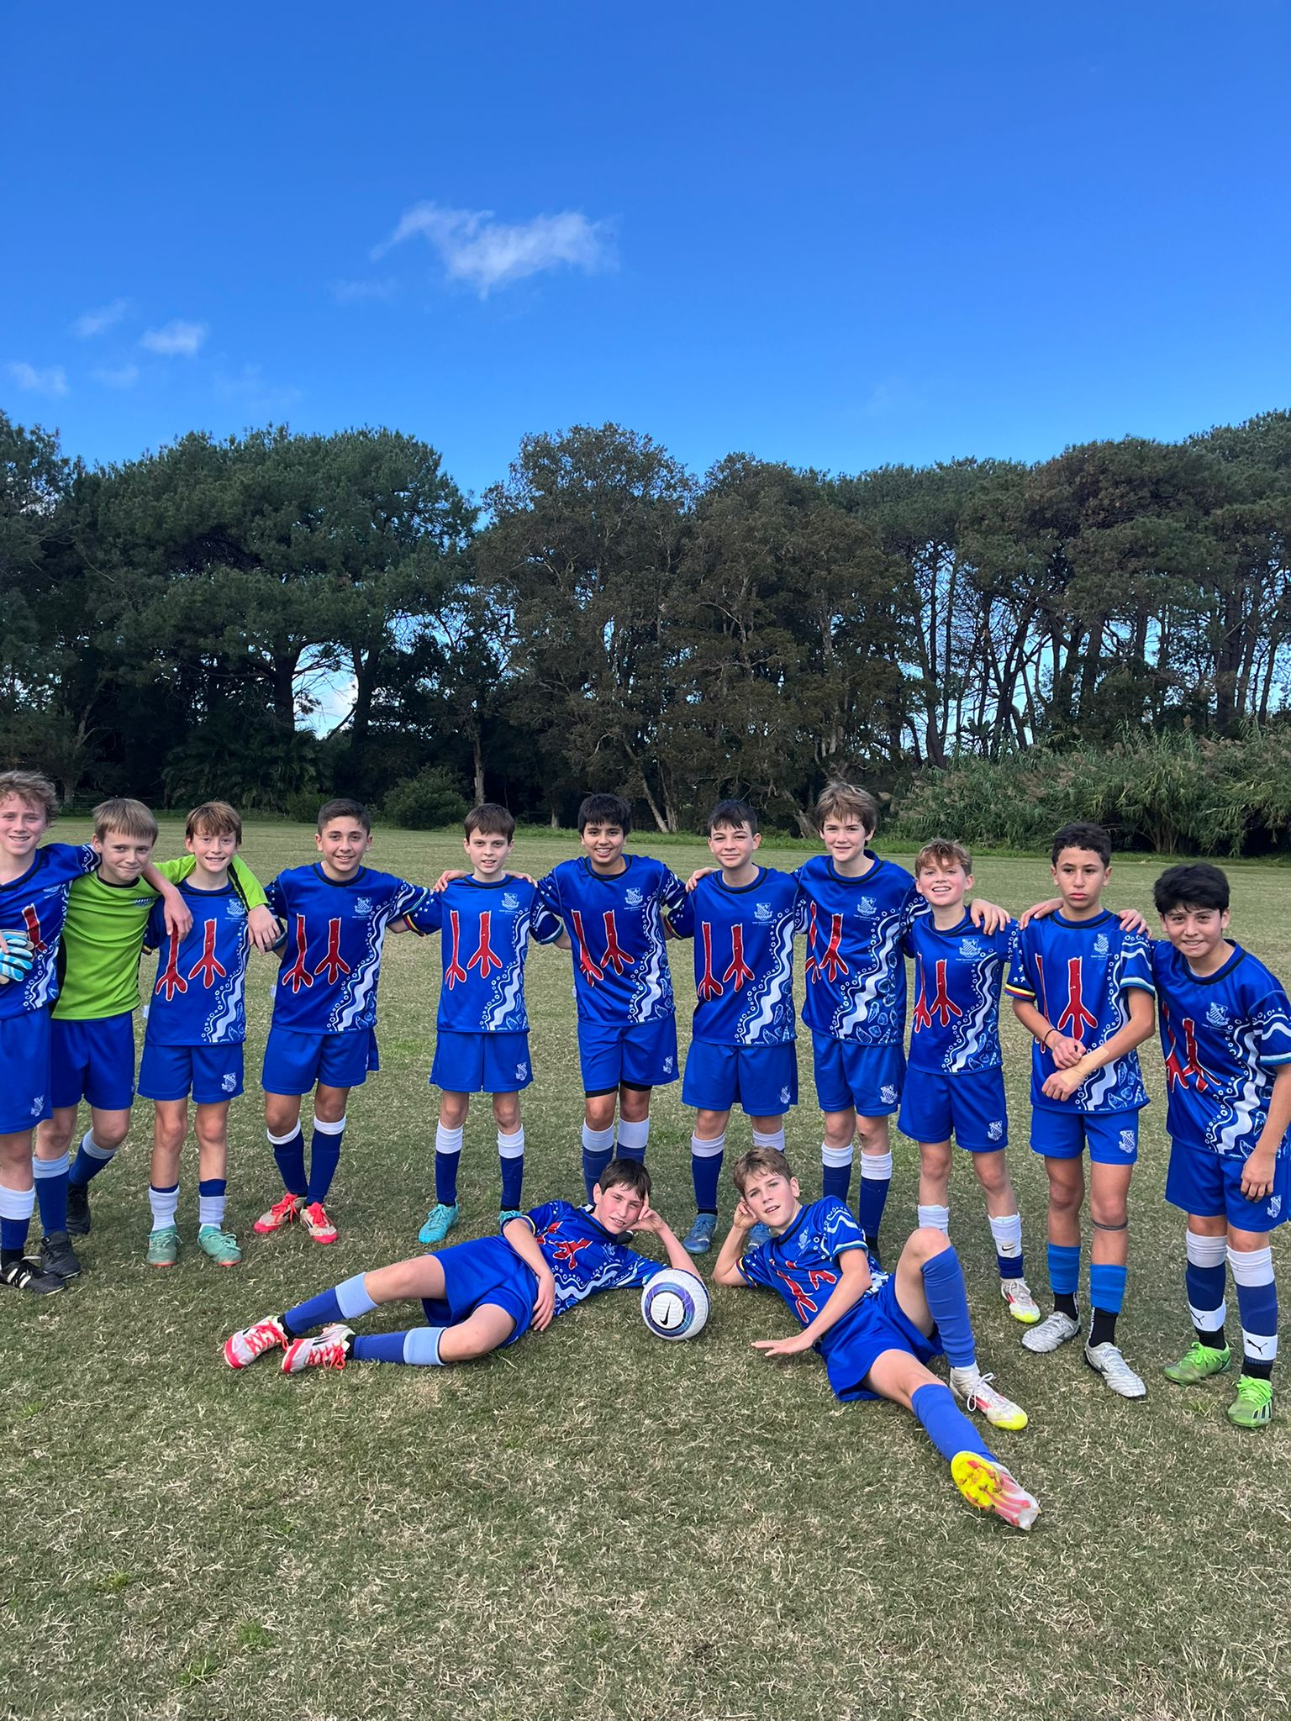
13A’s Match Report: Coach Zac Kalogerou
The Riverview 13As kicked off their GPS season with an impressive 3–1 win over Sydney Boys High, showing resilience and class to overturn an early deficit. Despite dominating possession in the opening stages, Riverview were caught off guard by a swift counterattack, with Sydney Boys High taking a 1–0 lead against the run of play. A well-placed shot slipped past Arlo Davis, putting the visitors ahead. Unfazed, Riverview maintained their attacking pressure, and just before halftime, Emmanuel Charry Vergara struck from long range, curling the ball into the far-right corner to level the score at 1–1. At the break, the team was encouraged to stay positive and play with courage. They responded immediately. The second half saw a marked improvement, with Sebastian Busco clinically finishing to give Riverview the lead. Not long after, Callum Donohue capped off a confident team display with a composed finish to make it 3–1. A strong start to the season and a well-deserved victory for the 13As.
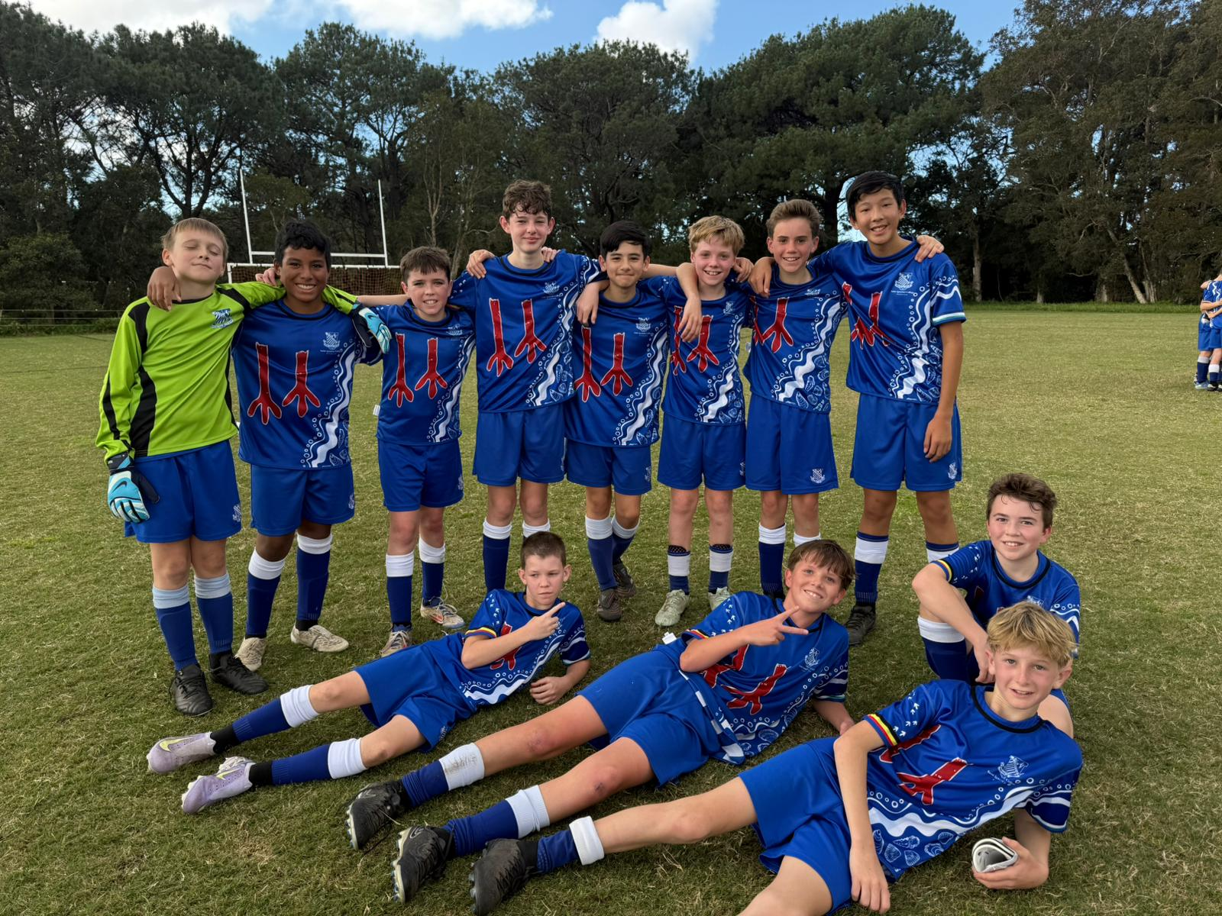
13B’s Match Report: Coach Domenico Garreffa
Riverview’s 13Bs delivered a dominant 5–0 victory over Sydney Boys High, controlling the match from the first whistle to the last. The team impressed with sharp passing, structured buildups, and relentless pressure after losing possession. Their ability to win the ball back quickly and limit the opposition's space was a standout feature throughout the match. Austin McMillan and Tom Payten each scored twice, demonstrating excellent positioning and clinical finishing. Marcus Strano added a fifth goal with a composed strike to round off the performance. Man of the Match honours went to Javier Bustamante, who dictated the tempo in midfield and played a key role in setting the tone for Riverview’s commanding display.

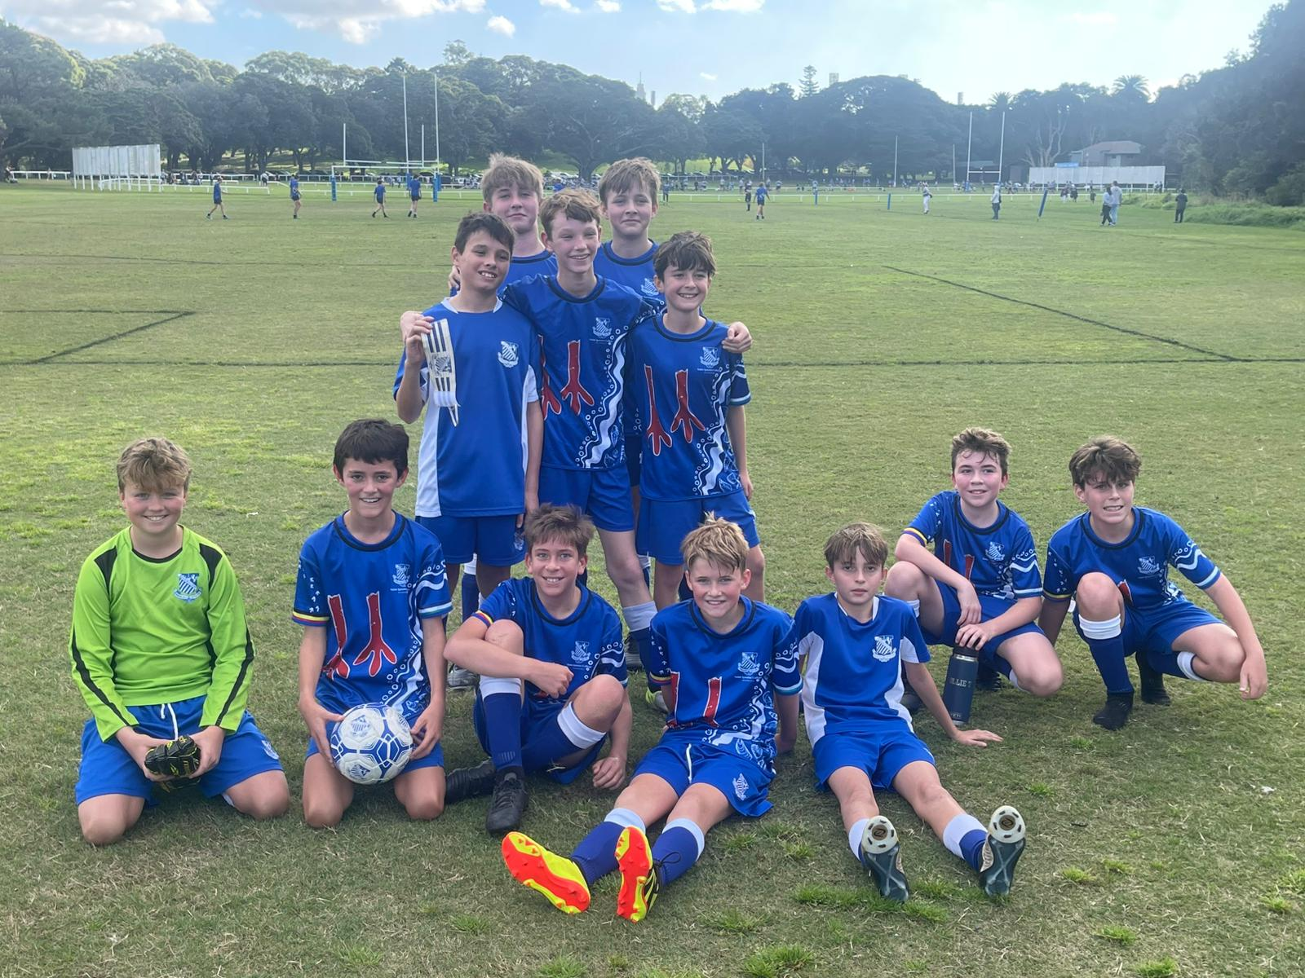
13C’s Match Report: Coach Tom Kalogerou
After last week’s washout and a tough loss to Joeys, the Riverview 13Cs returned determined to bounce back and did so in style with a dominant 10–0 win over Sydney Boys High. Having previously beaten the same opposition 3–0, the focus this time was on improving our finishing and the boys certainly delivered. Zach Hammond led the scoring with four goals, including a stunning top-corner strike and a composed brace on either side of halftime. Lucas Korbel finished off a slick passing move, while Noah Gatt added two sharp goals: one a crisp volley, the other expertly placed across the face of goal. Elliot Johnston also claimed a brace, including a late poacher’s effort, and James Hopkins slotted home after a surging run from midfield. While the attack dazzled, it was Liam Bortolussi’s leadership at the back that ensured a clean sheet, marshalling the defence with composure and authority. A complete team performance full of hunger, control and cohesion. A promising sign for the weeks ahead.
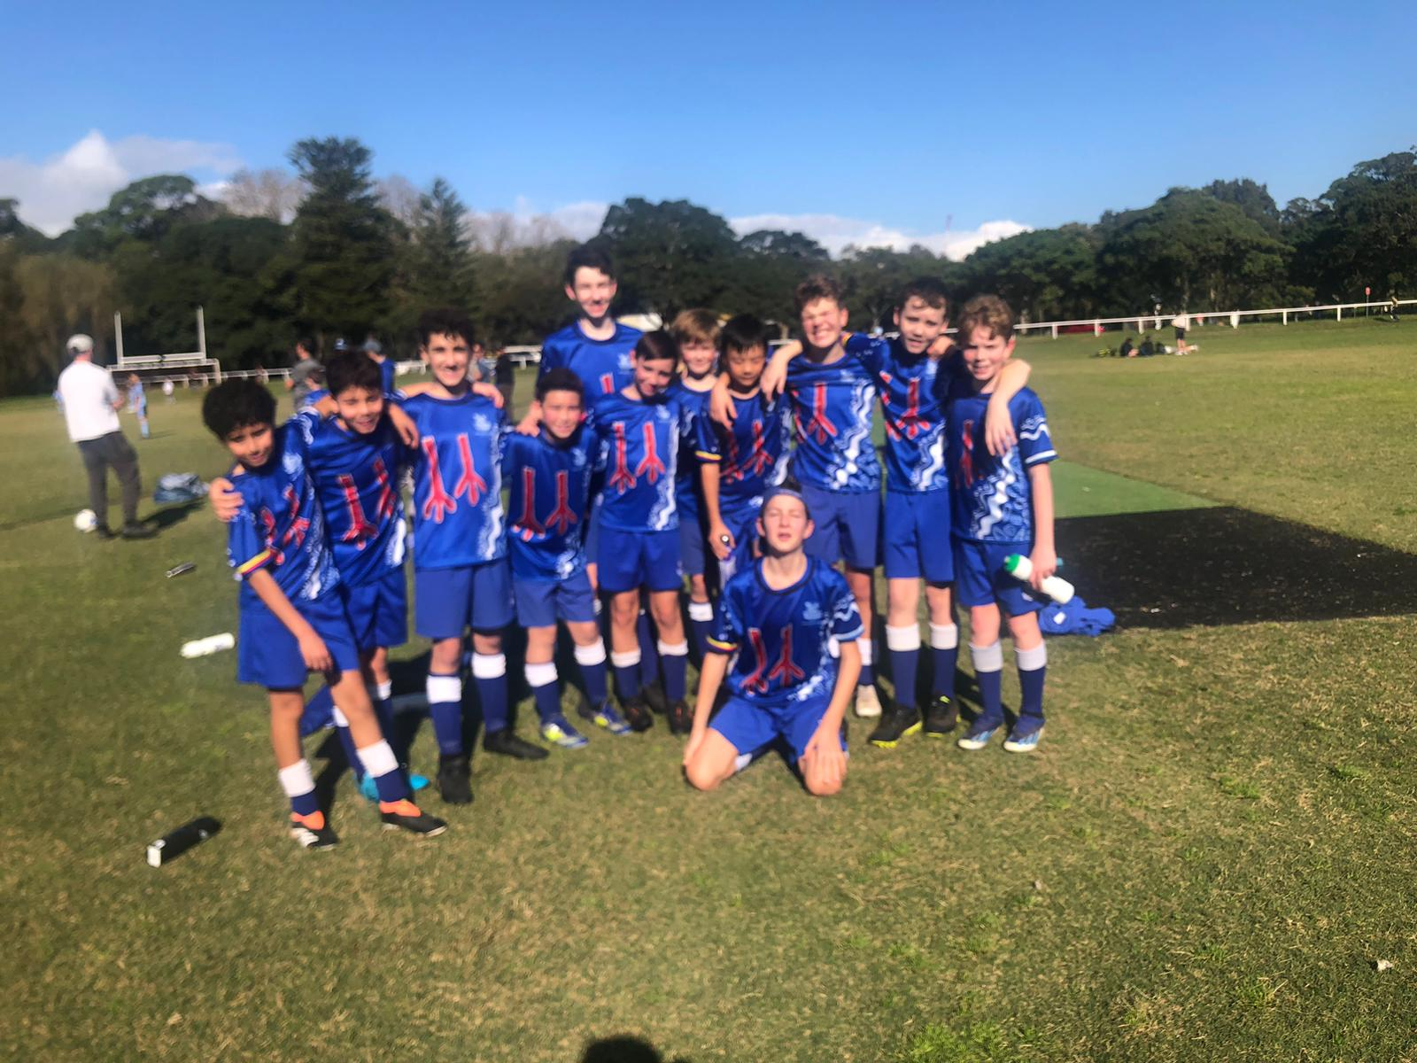
13D’s Match Report: Coach Marcus Kulukovski
The Riverview 13Ds faced Sydney Boys High over the weekend and came away with a hard-fought 2–1 victory. Riverview dominated possession early but struggled to convert chances. Their pressure was finally rewarded when Jacob Mikhael delivered a pinpoint cross that Xavier Salameh calmly finished, giving Riverview a deserved 1–0 lead. However, the advantage was short-lived, as Sydney Boys struck back with a swift counterattack to level the game just before halftime. The second half mirrored the first, with Riverview largely camped in the opposition half, controlling the tempo. Their persistence paid off when Toby Pool provided an incisive pass that was finished brilliantly by Jacob Mikhael, putting Riverview ahead 2–1. Late drama unfolded in the final minute when Sydney Boys were awarded a penalty. With the result hanging in the balance, goalkeeper Henry Wotton stepped up and made a stunning save to secure the win. A gritty and composed performance from the 13Ds, marked by teamwork, resilience, and a moment of brilliance when it mattered most.
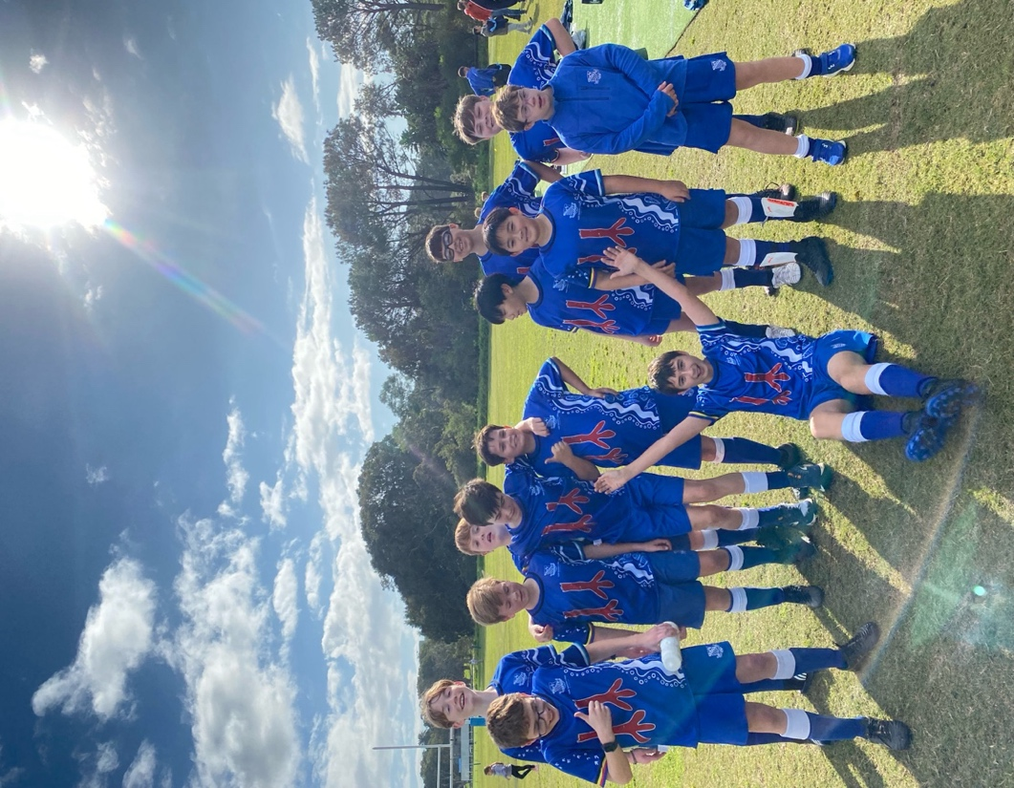
13E’s Match Report: Coach Charlotte Afeaki
The 13Es kicked off their season in exciting fashion with a 2–2 draw against Sydney Boys High. Having defeated the same opposition a few weeks ago, the team entered the match with confidence but were quickly stunned by an early goal from Sydney. That proved to be the wake-up call Riverview needed, as the boys shifted into a higher gear. James delivered a fantastic performance in defence, while Michael kept the team qualizer with strong communication. At halftime, tactical changes were made. Jayden volunteered to go in goals, and Xavier came out for a run, immediately making an impact by scoring the qualizer. Flynn steadied the midfield, supported on the flanks by the two dynamic Alexes. Although a fortunate penalty gave Sydney a second goal, Riverview never gave up. Fergus came through in the final moments, sealing the draw with a dramatic late goal. Special mention to Jacob for his positive energy and encouragement throughout: a great team effort all around!
YEAR 8
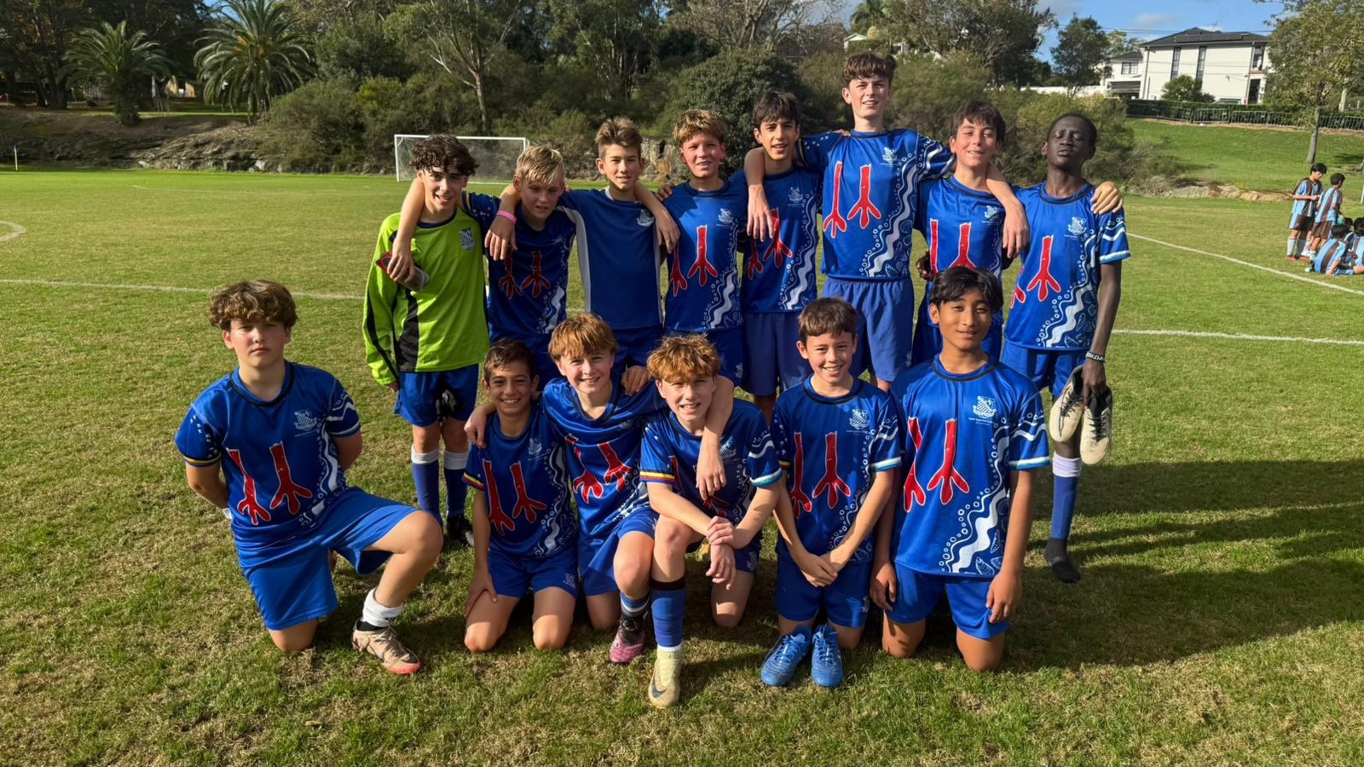
14A’s Match Report: Coach Roberto Fausti
Riverview secured a well-earned 4–2 victory over Sydney Boys in an entertaining and competitive encounter. Despite a promising start, an early lapse in concentration led to a defensive error and the opening goal for Sydney Boys. However, the team responded with poise and urgency. Two sharp attacking moves saw Hugo and Noah find the back of the net, giving Riverview a 2–1 lead. Sydney Boys later equalised following another defensive mishap, but Riverview’s resilience shone through. A key contributor to the win was Max, who stepped up from the B team to replace injured goalkeeper Nicholas. He impressed with a calm and confident display. Alonso and Will also stood out with strong performances and excellent teamwork. James R. restored the lead with a composed finish, and Noah secured the result with a confidently taken penalty (his second goal of the match). While defensive organisation remains an area for improvement, the squad’s spirit, style of play, and growing cohesion are all positive signs for the season ahead.
Man of the Match: Noah – A standout performance capped with two crucial goals.
14B’s Match report (no photo available):Coach Lachlan Easdown
On a glorious Saturday morning, the Riverview 14Bs hosted Sydney Boys High for a much-anticipated rematch, following a tightly contested 1–1 draw earlier in the season. The opening stages saw an open, end-to-end contest. Riverview had to work hard to impose their style against a direct Sydney Boys side, who again looked to exploit space behind with long balls down the middle. Once the early nerves settled, it became clear which team had the greater intent and cohesion. Riverview began to dominate possession through sharp transitional play. Sam linked well from the back, feeding Alonso in midfield, who combined cleverly with Max at No. 10 and wingers Ben and Jake, later joined by Oscar and Finn to carve through the Sydney defence. While several promising moves fell just short of a final ball, the intent and build-up were impressive. One of the standout moments of the match came from a brilliantly executed sequence starting with Lachie Galofaro’s trademark 20+ meter throw-in to Will Hall. Will produced a classy turn, played a bounce pass to Alonso, who found Oscar: his effort narrowly missing the top corner in what would have been a fitting finish to a superb team move. Will Hall was a consistent threat throughout the match, especially in the second half when he dropped into the No. 10 role, expertly orchestrating play in the final third. A special mention goes to Enzo and Lachie Nink, who played out of position but were instrumental in maintaining defensive shape and nullifying any Sydney attacks in the final third. Looking ahead, the focus will be on continuing to develop our combination play in the final third. Greater directness and precision in these moments will increase our ability to test opposition keepers. In addition, committing to our expanded width in possession will open the half-spaces, giving us even more attacking options and control.
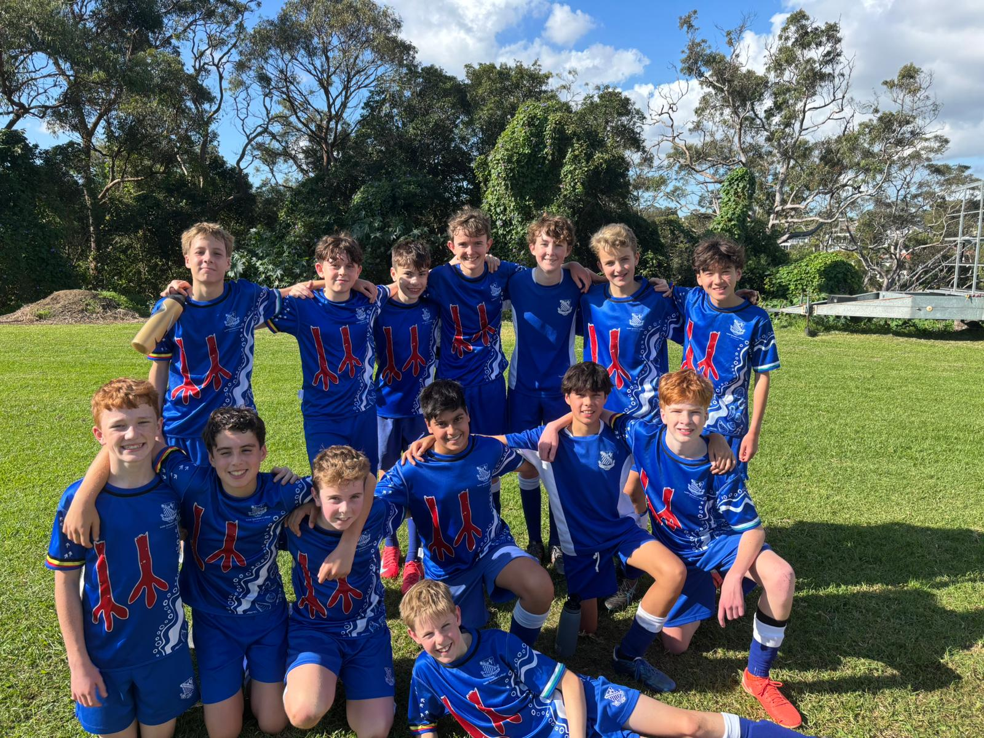
14C’s Match Report: Coach Mark Musumeci
Riverview secured a hard-fought 1-0 victory over Sydney Boys High in a match where the scoreboard didn’t quite reflect the dominance on display. Despite controlling possession and creating numerous scoring opportunities, the team found it challenging to convert chances, leaving the score goalless at halftime. The breakthrough finally arrived late in the second half when Nicholas Hudson calmly stepped up to score the decisive goal, rewarding the team’s persistence and attacking intent. From start to finish, the boys played with great passion and enthusiasm. William Carney was outstanding at center back, using his pace and positioning to shut down threats and command the defence. Teddy Murray was equally impressive between the posts, confidently coming off his line to deny Sydney Boys High any clear opportunities. Thomas Johnson’s energy and leadership shone throughout the match, rallying the team at crucial moments and maintaining strong team spirit. While the result was a positive step forward, there’s clear room for improvement in clinical finishing. To address this, this week’s training will focus on sharpening the team’s ability to convert chances: a vital skill for securing more comfortable wins against stronger opposition in upcoming fixtures.
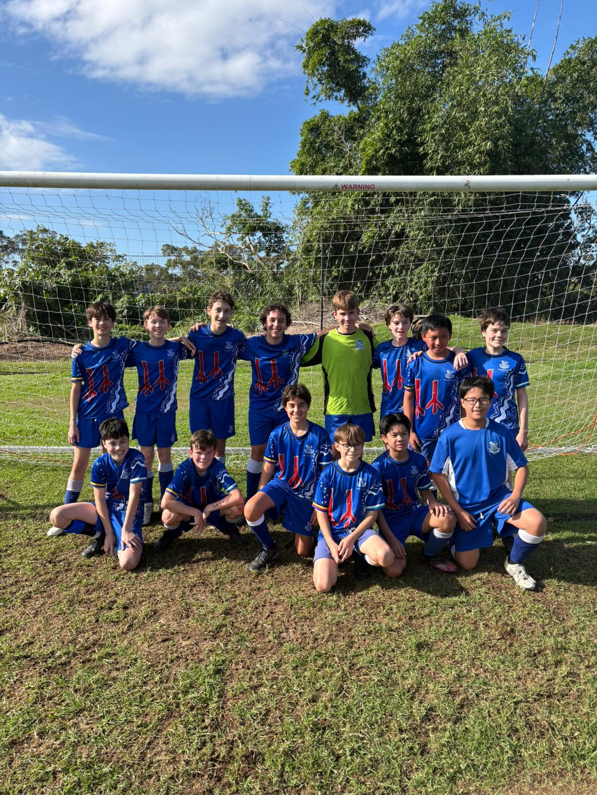
14D’s Match Report: Coach Lachlan Iacono
This weekend, our 14Ds faced Sydney Boys High for the second time in just two weeks, after a goalless 0-0 draw in their first meeting. The team started the match with a few notable absences, including Jason Herrera-Hu and goalkeeper Nathanial Mardon. Despite a lingering toe injury, Jordan Herrera-Hu showed great determination by joining the game in the second half. To bolster the squad, Patty and Marcelo stepped up from the E’s team to assist. Early in the first half, Sonni broke through Sydney Boys’ defensive line with a perfectly timed through ball to Tim, who calmly slotted it home. The defensive line (Nicholas, Leo, Henry, James, and Dom) stood strong, effectively shutting down long balls over the top, a key weakness from their previous encounter. Tim doubled his tally before halftime, making it 2-0. In the second half, the D’s looked to put the game beyond doubt but were unable to convert several important chances. Marcelo, who had already played a game for the E’s, was substituted for James McAllan, who worked tirelessly to help maintain the clean sheet despite a few minor slips. Jordan Herrera-Hu, recovering from injury, came on with 10 minutes to go and made an immediate impact. The ball was played out from the back to Jordan, who took what appeared to be a harmless shot. However, the uneven surface of the second field caused difficulties for the goalkeeper, allowing the ball to find the net and seal a 3-0 victory. This result showcased major improvement from the 14Ds, beating a side they had previously drawn with: a testament to their dedication and progress in training.

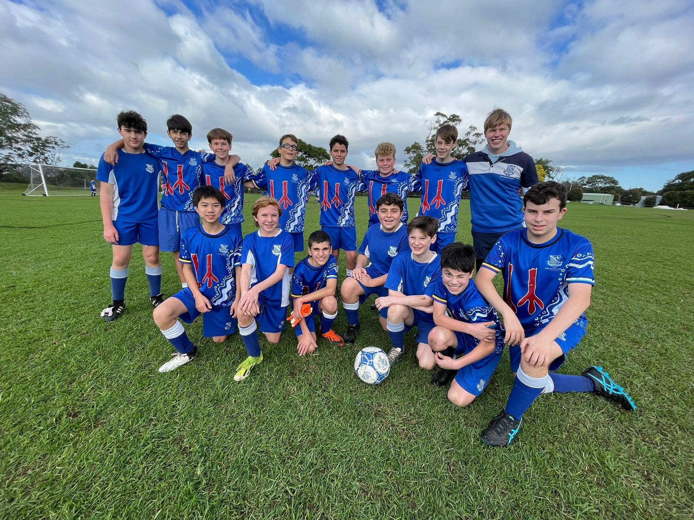
14E’s Match Report: Coach Gabriel de Haast
The boys started the game strongly, showcasing skill and creativity in the attacking third with an early chance that nearly found the net. The opposition proved tough, but our defence remained solid, holding a strong line throughout the match. Will in goal made several crucial saves late in the first half, keeping the score level as the whistle blew for halftime. In the second half, a tactical switch to a reliable 4-4-2 formation helped develop our central attacking play, creating growing pressure that worried the opposition. The boys executed the game plan to near perfection, delivering effective balls through the line just as they had in the first half. Despite the attacking promise, both teams were unable to find the decisive finish, and the match ended in a hard-fought 0-0 draw. The team should be proud of their effort and discipline throughout the game.

Year 9

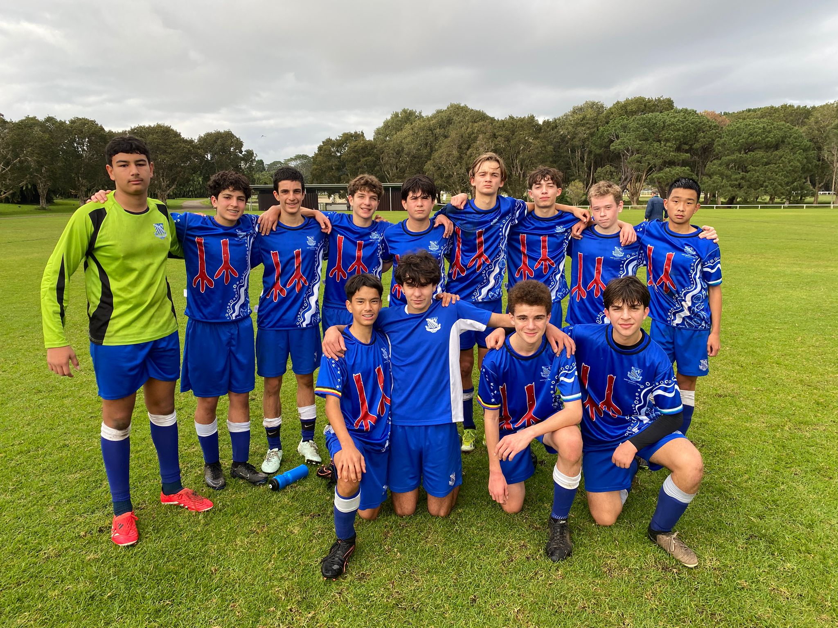
15A’s Match Report: Travis Cooper
The U15As were held to a 2–2 draw by Sydney Boys High in a match full of both moments of brilliance and frustration. The boys began strongly, racing to a 2–0 lead in the first half. James Dart marked his debut with a well-taken goal, finishing off a precise header assist from Buffett. Shortly after, Louie doubled the lead with a stunning volley: expertly chesting the ball down before striking it sweetly into the net. Despite this bright start, Sydney Boys fought back. A well-placed cross found a teammate at the back post to pull a goal back, and a thunderous long-range strike soon levelled the scores. Although the result was disappointing given the early dominance, the team can take confidence from their first-half performance and moments of individual quality. Attention now turns to the upcoming Bill Turner Cup clash against Knox, where the boys will aim to bounce back.

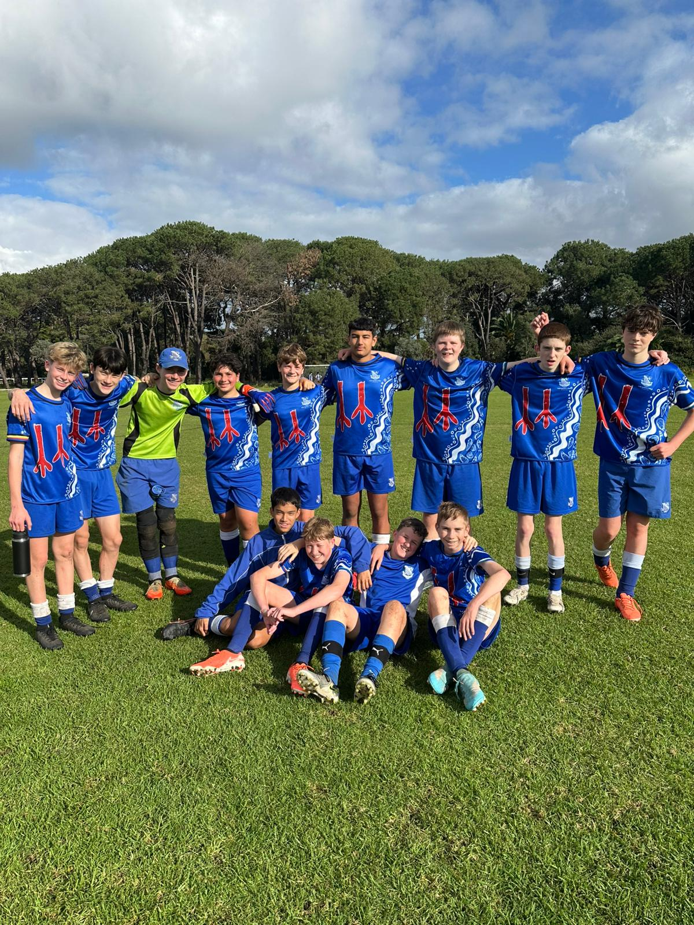
15B’s Match Report: Coach Josh Engelman
The 15Bs returned to the grounds of Centennial Park eager to secure a win on the first day of the GPS season. Having drawn their preseason encounter against Sydney Boys, today the team was determined to claim all three points. Riverview started strongly, creating several threatening chances through shots on goal and effective link-up play. However, as the second half progressed, Sydney Boys found a second wind. Midway through the half, they capitalised with a superb strike into the top right corner, taking the lead. Undeterred, the 15Bs continued to press forward. Their persistence paid off when Xavier skillfully worked his way into the box and scored a well-earned equaliser, making it 1-1. As the match entered its final moments, Sydney Boys mounted one last attack and managed to score, securing a 2-1 victory. Despite the loss, the team showed great resilience and attacking intent, laying a solid foundation for the season ahead.
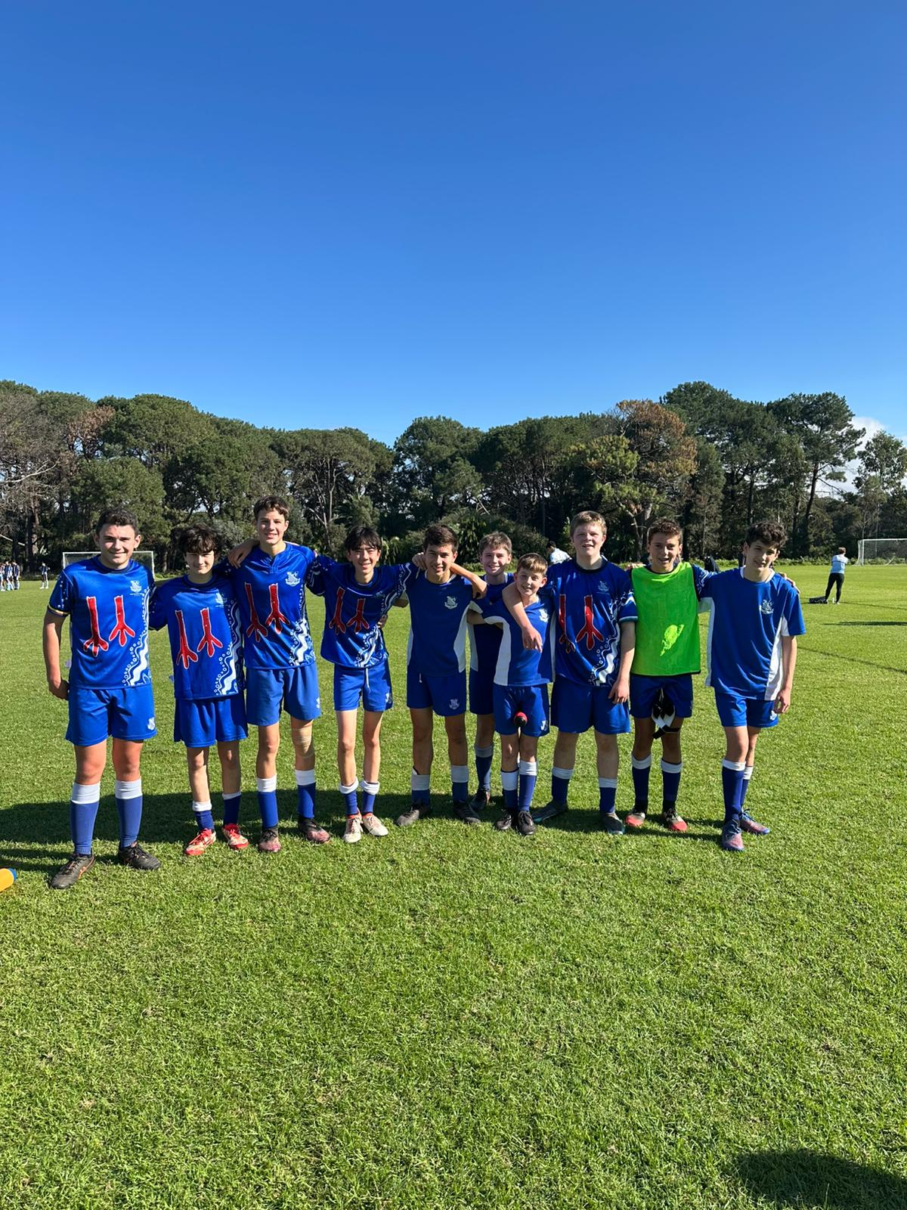
15C’s Match Report: Coach Josh Engelman
The 15Cs returned to Centennial Park for the return fixture against Sydney Boys High, eager to secure a win. From the outset, the match was an even contest, with both sides trading attacking moves and creating plenty of chances. Riverview applied consistent pressure throughout, combining well in midfield and forcing Sydney Boys onto the back foot. Clever link-up play and attacking intent kept the opposition defence busy, with Riverview controlling large stretches of the game. However, it was Sydney Boys who struck first, capitalising on a passing move through the middle to take a 1–0 lead in the first half. Despite the setback, the Riverview boys remained composed and committed to playing their style of football as trained. The pressure continued in the second half, with Patrick delivering a series of dangerous balls from corners and wide areas. Still, the final touch eluded the team, and the equaliser never came. While the result was disappointing, the effort, discipline, and execution were strong. The boys should be proud of their performance, and as I reassured them post-match if they continue working hard, the wins will follow.
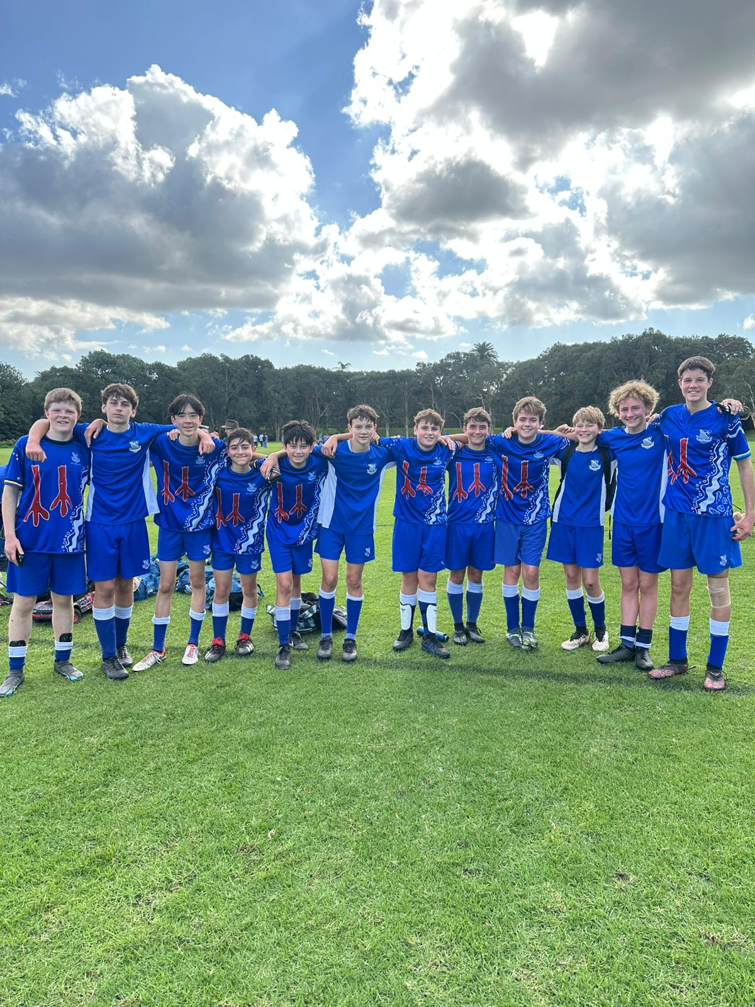15D’s Match Report: Coach Josh Engelman
The 15Ds returned to Centennial Park to face Sydney Boys High in the opening round of the GPS season. Having drawn with them in a preseason fixture just weeks earlier, the team arrived fired up and eager to start the campaign with a win. The game began with promise, as Riverview’s midfield trio of Brodie, Ben, and Remy linked up well with the attacking line to create early pressure. The boys pushed forward with intent, making deep runs and forcing Sydney Boys to defend for long periods. Despite dominating large portions of the first half, the sides went into the break locked at 0–0. In the second half, Riverview continued their attacking push, but a lapse in numbers at the back allowed Sydney Boys to counter and break the deadlock. The boys responded positively, creating several chances: with shots narrowly missing the target and keeping the pressure high. Unfortunately, in the final moments of the match, Sydney Boys capitalised again. A long, hopeful pass from deep found their striker one-on-one with the keeper, and he finished clinically into the bottom corner to make it 2–0 with virtually the last kick of the game. At full time, I reminded the boys that the scoreline didn’t reflect the quality of their play. Their effort, structure, and commitment were clear and there’s every reason to be excited for what’s to come next week.
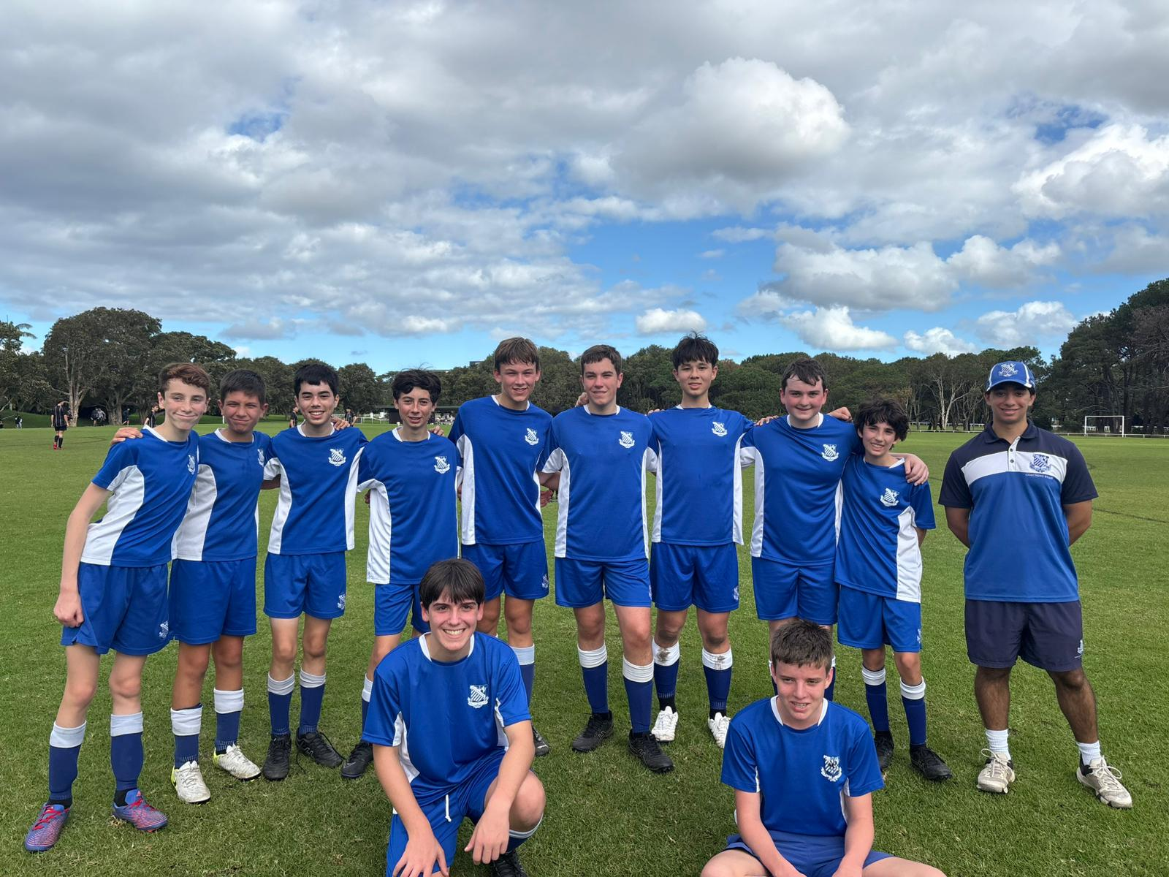15E’s Match Report: Coach Joseph Salameh
This Saturday, the 15Es returned to Centennial Park for a rematch against Sydney Boys High. After an 0–8 result in their previous meeting, the team came in determined to show how far they’d come and they did just that. The first half was tightly contested, with Riverview creating two excellent chances. Christian came close to opening the scoring, and Xavier had a great opportunity to double the lead, but both efforts were denied by strong goalkeeping. The boys showed excellent energy, discipline, and hustle, keeping the game on a knife’s edge. Unfortunately, just before the break, Sydney Boys broke through and went ahead 1–0. In the second half, Riverview continued to battle hard. Jules delivered an outstanding performance in goals, making several crucial saves to keep the team in it. Xavier and Christian ran tirelessly all game, putting pressure on the opposition. Will stood tall at the back with some great defensive plays, while Joey was once again a model of consistency. The final score of 0–3 was a big improvement on the last fixture and with a bit more luck in front of goal, the outcome could have been very different. The team should be incredibly proud of their progress, and there’s plenty to build on heading into the coming weeks.
YEAR 10
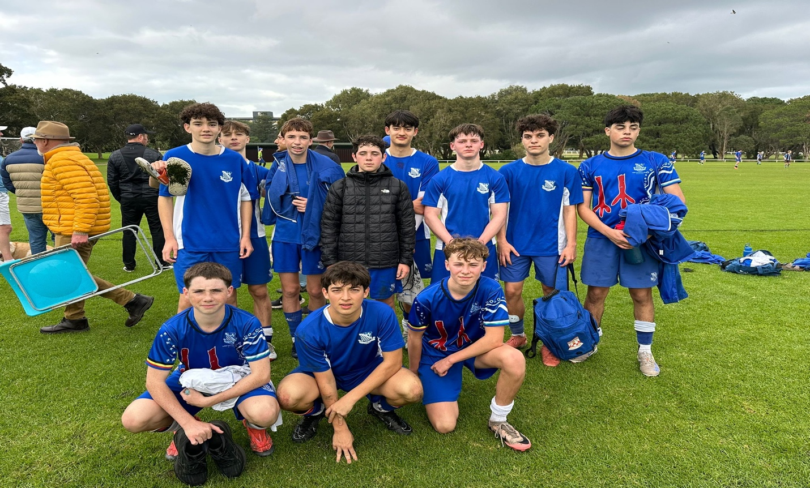
16A’s Match Report: Coach Nic Kalogerou
After several weeks off since their emphatic win over Grammar, the 16As returned to action eager to pick up where they left off and they certainly delivered. Facing a well-drilled Sydney Boys High side in the opening round of the 2025 Winter GPS season, the boys put on an impressive display of attacking football and team cohesion. Right from the opening whistle, Riverview showed their intent. Within five minutes, sharp combination play at the edge of the High penalty area saw Stacky break through on goal, only to be brought down by the keeper. He stepped up and calmly converted the penalty to give View an early 1–0 lead. Well done, Stacky! Minutes later, Lucas delivered a quality ball into Marcus, who held it up superbly before threading a perfect pass through the defence to Sam. Sam made no mistake with the finish. 2–0 Riverview and a fantastic team goal. Great work from Marcus and Sam! While High’s biggest threat came from a pacey striker, Riverview’s defence: Charlie, Muz, Drew, Owen, Indra, and Henry (a big thanks for stepping in!) held firm. Their discipline ensured a clean sheet at the break.
Half-Time: 2–0 Riverview
The second half started with a lapse in focus, allowing High to capitalise with a quick break and cut the lead to 2–1. However, true to form, the boys responded swiftly. Marcus again showed his class with another composed assist to Stack, who slotted home his second of the match, restoring the two-goal cushion. Then came one of the goals of the day. Alex weaved through several defenders, linked up neatly with Xavier in midfield, and found Sam on the flank. Sam beat his marker and drilled the ball into the net for his second of the game. Brilliant team play and a well-deserved brace for both Stack and Sam! High managed to pull another goal back late in the match, but Indra produced a crucial late save to secure the 4–2 win. A strong, composed performance to open the GPS season.
Final Score: Riverview 4–2 Sydney Boys High
A special mention to both Henry and Owen, who not only played vital roles in the A’s match but backed it up immediately after for the B’s, showing great character and commitment. Thank you, both.
And finally, a big thank you to all the parents who braved the usual navigation maze that is Centennial Park — we hope you enjoyed the game and your weekend!

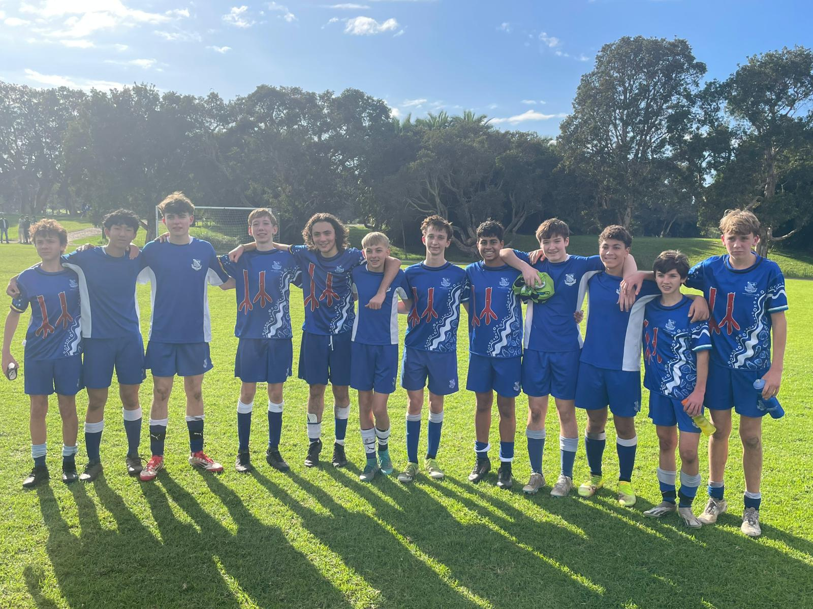
16B’s Match Report:Coach Stefan Visscher
Looking to maintain their unbeaten start to the season, the 16Bs came into their clash with Sydney Boys High full of confidence and they made a statement early. The game opened with a slick passage of play through the midfield, culminating in Harry Saadat delivering a pinpoint cross to Jules, who finished neatly into the bottom corner. The momentum continued in the 12th minute when Austin launched a brilliant 40-yard free kick directly to Finn, who laid it off to Lucas Yassa to slot home Riverview’s second goal. A well-worked team effort and a dream start at 2–0. However, with the early cushion, the boys began to lose focus, taking too many touches and allowing High back into the match. Their striker capitalised with a top-corner finish in the 22nd minute to halve the deficit. At halftime, the focus was on tightening up midfield decision-making and improving the press on opposition goal kicks. Despite the adjustments, High struck again just four minutes into the second half, levelling the score at 2–2. But Riverview showed real heart and resilience. Fighting for every loose ball and regaining control of the match, their efforts were rewarded when Lucas Yassa struck again, this time with his left foot and calmly finishing into the bottom right corner to restore the lead. The game finished 3–2, a deserved win for a team that showed both class and character. While there’s still plenty to improve on, the boys should be proud of their response and determination. Looking forward to building on this in the week ahead.
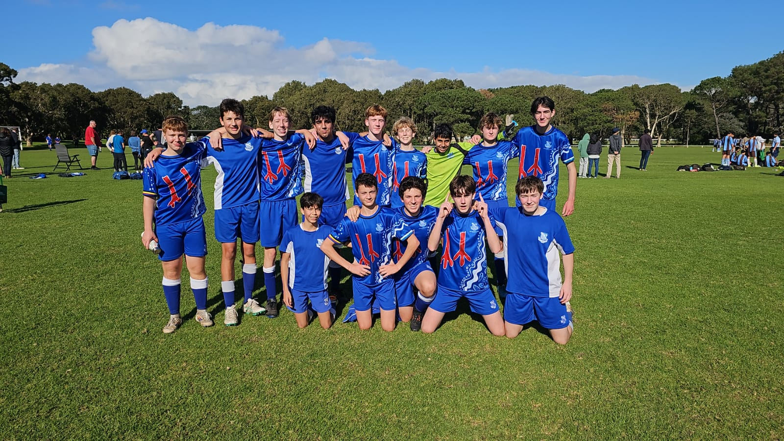
16C’s Match Report: Coach Jacob Stevens
This past Saturday, the squad travelled to Centennial Park to face Sydney Boys High School, determined to bounce back after two consecutive defeats. With a focus on improving our passing, movement, and defensive pressure, the boys took to the pitch with purpose and intensity. From the outset, Riverview displayed a determined and aggressive approach, showing strength in the tackle and intelligent movement off the ball, offering consistent passing options throughout the pitch. Will Thomas was a standout in midfield, setting the tone early with accurate passing, composed dribbling, and strong challenges: a commanding presence in the heart of the team. We opened the scoring through Jack Stanic, who fired a powerful strike low to the keeper’s right. Henry Russell impressed on the left flank, showcasing excellent close control and consistently troubling the Sydney Boys defence with his footwork and creativity. Early in the second half, Joe Girard extended the lead with a well-taken finish to the keeper’s left, capping off another flowing team move. The highlight of the day came courtesy of Owen Hoy, whose speculative long-range strike looped over the keeper to seal a memorable win. Overall, it was a complete team performance, a day of positive football, renewed confidence, and great spirit. The result sends the squad into the long weekend break on a high note, ready to build on this momentum in the coming weeks.
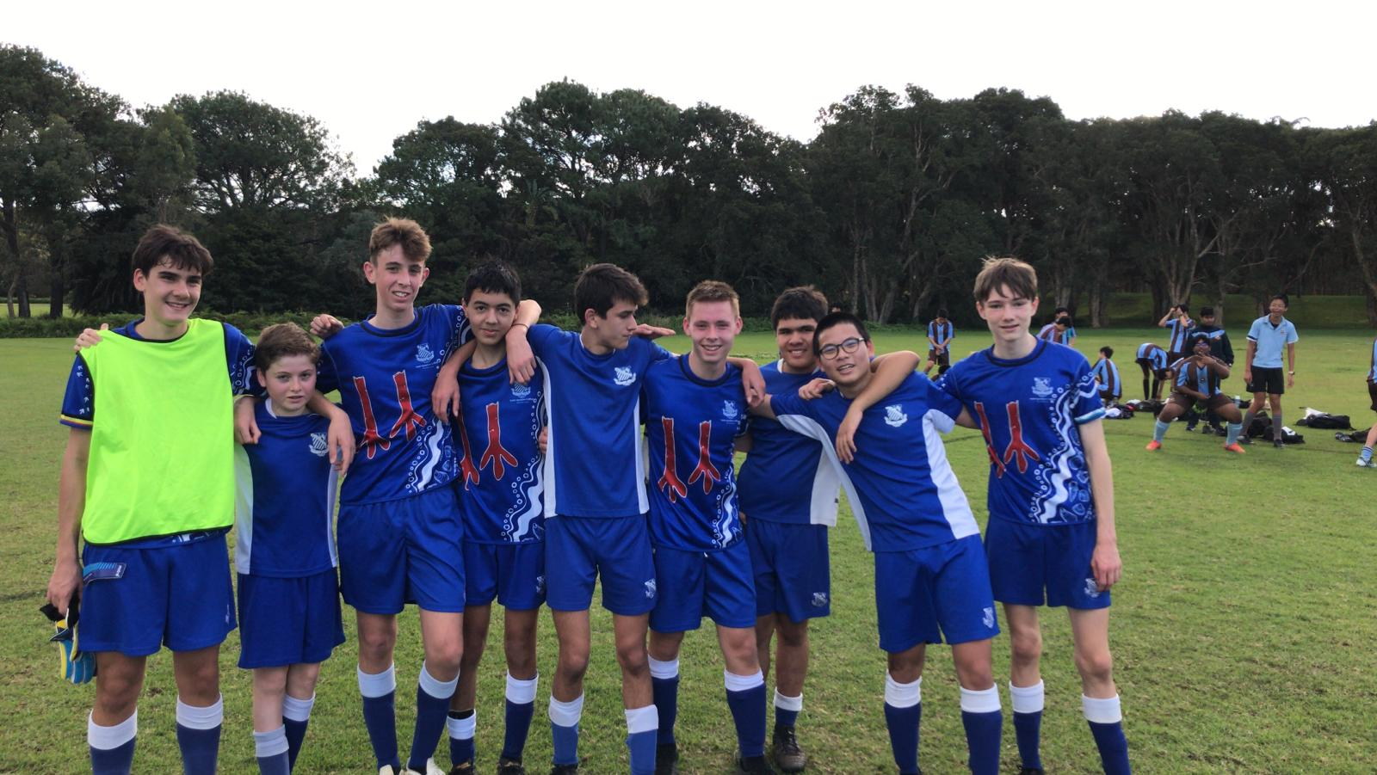
16D’s Match Report: Coach Harold Bonnington On a crisp autumn Saturday at Centennial Park, the 16Ds faced Sydney Boys High under challenging circumstances, fielding only nine players. Despite being undermanned, the team displayed tremendous spirit and resilience from the opening whistle. The early stages of the match were a stalemate, with Riverview’s determined defensive unit standing firm. Elliot Solomons made several strong saves in goal, and the defensive discipline kept the opposition at bay. A moment of promise came with a brilliant counterattack, as Nathan Brooks made an inspirational solo run that nearly led to a breakthrough: a testament to the team’s fighting spirit. Although three goals were conceded before halftime, the Riverview side refused to fold. The second half was marked by the same perseverance, with players continuing to give their all in both attack and defence. Nathan Brooks, having controlled the midfield in the first half, switched to goalkeeper in the second and produced a number of impressive saves. Jack Winter, solid in defence, made several enterprising attacking runs, while Arthur Lusher worked tirelessly on the wing, covering ground and showing real commitment. Despite the 5–0 final score, the performance was a display of grit, unity, and character in the face of adversity. The boys should be proud of their effort, it was a commendable performance under difficult conditions, and one that truly reflected the Riverview spirit.
OPEN SQUADS
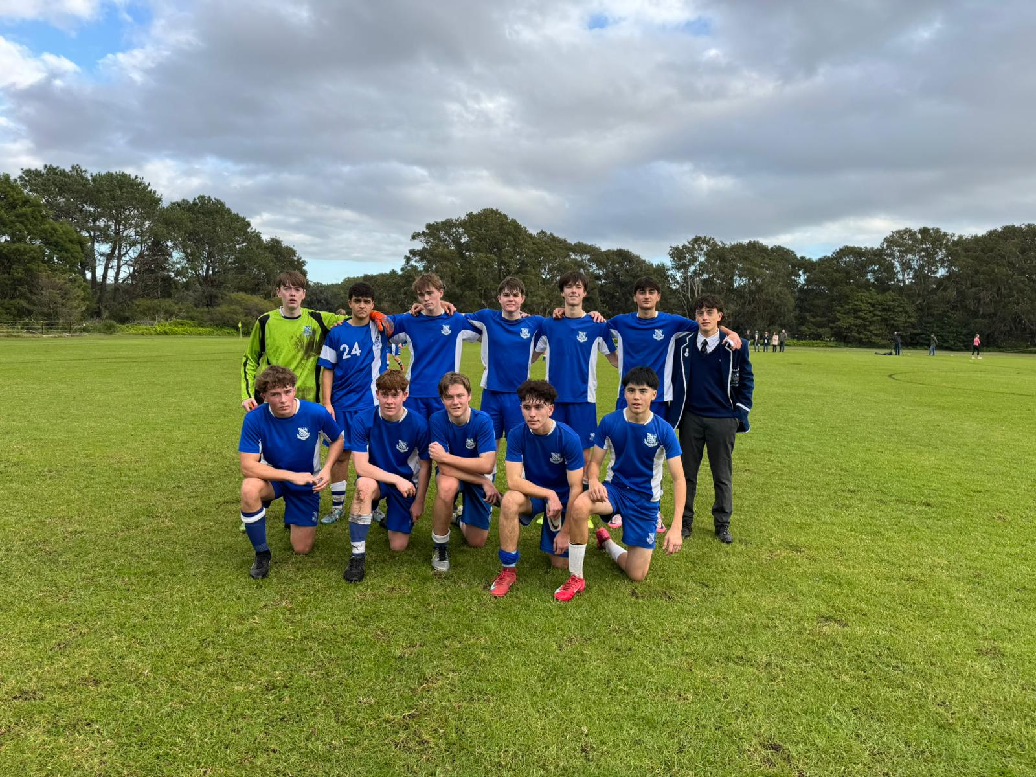
3rd Match Report: Coach Stefano Rossello
The 3rds football team kicked off the GPS season against Sydney Boys High, following a dominant 4-0 victory over the same opposition last time. The boys were eager to build on that success and improve their performance. The game started slowly for Riverview, with a noticeable lack of concentration and energy. Sydney Boys High looked poised to open the scoring early on, but some crucial saves from Will kept us in the contest. The momentum shifted as we began to control the midfield, and it wasn’t long before Josh McKenzie opened the scoring with a superb shot from wide, lofting the ball over the keeper’s head. Shortly after, Jake delivered a perfect corner into the box, which Josh was able to convert again, doubling our lead before halftime. The team’s confidence grew, and they took firm control of the game. The second half began with a handball from the opposition that awarded us a penalty, calmly converted by Nick Dsouza, who made a strong return from injury. Despite creating further chances, we couldn’t extend the scoreline, but the boys’ quality was enough to secure a 3-0 victory in round 1. Moving forward, the team will focus on refining attacking patterns and maintaining shape to prepare for next week’s fixture.
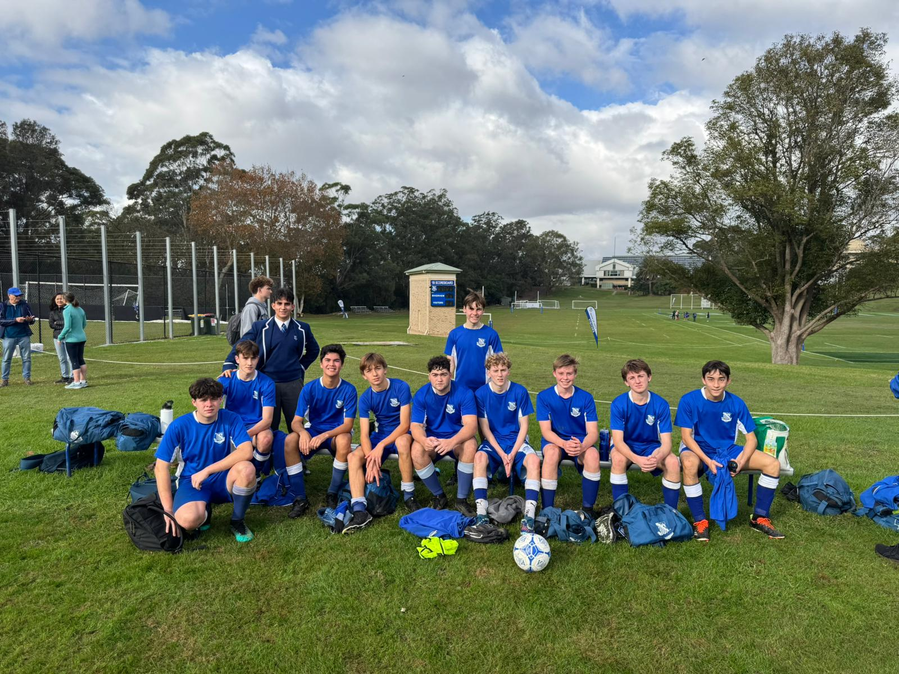
4th Match Report: Coach Jack Aman
This week, the 4ths faced a tough test against a strong Sydney Boys High side, who posed difficulties right from the opening kickoff. Their quick and skillful attackers created numerous chances, particularly in the early stages, testing our defence extensively. After some initial adjustment, our team found their rhythm and produced arguably the best 10–15 minutes of the season toward the end of the first half. During this period, we created several promising opportunities but were ultimately unlucky not to find the back of the net. In the second half, we aimed to build on this momentum, but despite our efforts, we couldn’t break through the opposition’s defence. There is clearly room for improvement, especially in our creativity and execution in the final third, which will be a key focus as the term progresses. Overall, it was a valuable learning experience, and the team remains committed to developing stronger attacking play moving forward.

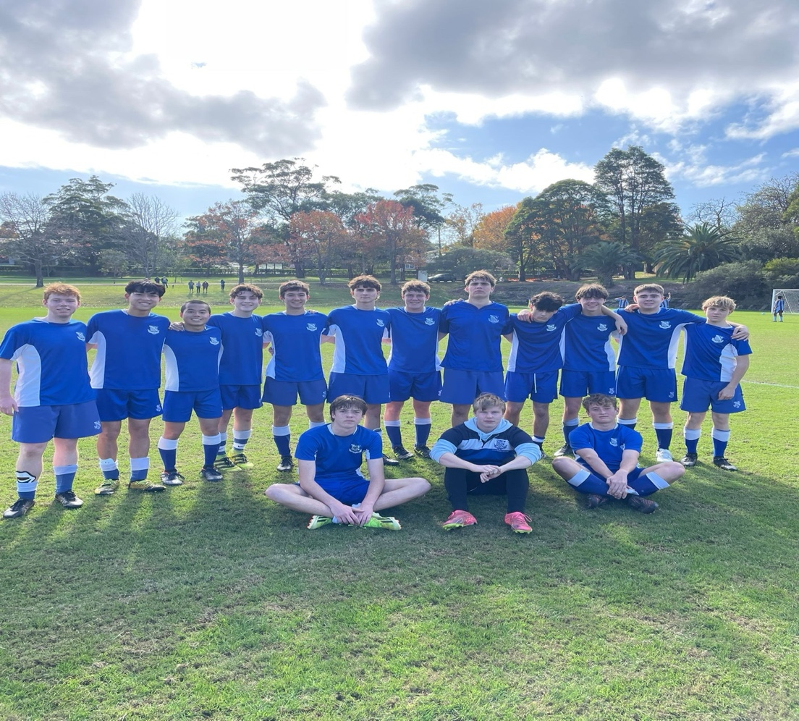
5th Match Report: Coach Gabriel de Haast
After a tough 5-1 loss to the same opponents a couple of weeks ago, the boys were determined to get revenge. They started the game with a lot of energy and intensity. However, the opposition struck early with two goals, igniting a fire in our team. Our attacks built quickly, culminating in a one-on-one situation where Sam Lewis was fouled just outside the box (a challenge clearly deserving of a red card). Hugo’s first free kick attempt hit the wall, but he calmly scored on the rebound to bring the score to 2-1 going into halftime. Unfortunately, the boys struggled to implement the game plan in the second half. Despite hitting the woodwork twice, they couldn’t find the equaliser and the game ended 3-1. There is plenty to work on, but also many positives to take forward.
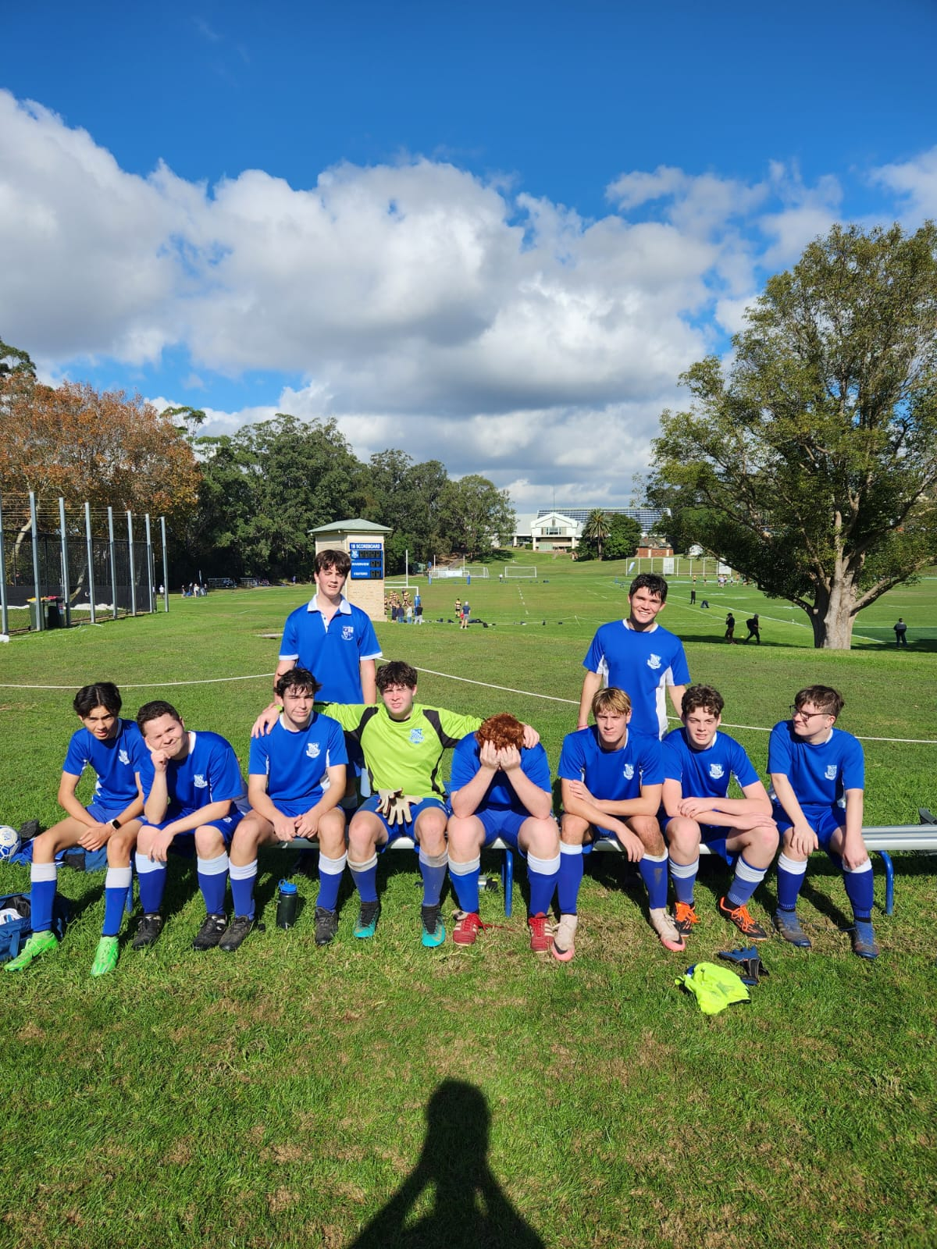
6th Match Report: Coach Maximus Joosse
Despite difficult circumstances, the team demonstrated great determination in a tough 0-4 defeat. Starting the match with only nine players, we were fortunate to borrow Ethan to even the numbers. Ethan gave his all until halftime when he had to leave. Our opponents took advantage early, scoring two goals in the first half. Nevertheless, we created several attacking opportunities and maintained our defensive shape well under pressure. Unfortunately, just before halftime, Matthew Zielinski suffered a dislocated kneecap, which further unsettled the team. In the second half, the team continued to fight hard, but with limited substitutions and fatigue setting in, we struggled to maintain intensity. The opposition added two more goals, but our players showed great heart and effort until the final whistle. While the final score was disappointing, there were many positives to take away, especially the resilience and adaptability the team displayed in the face of adversity.
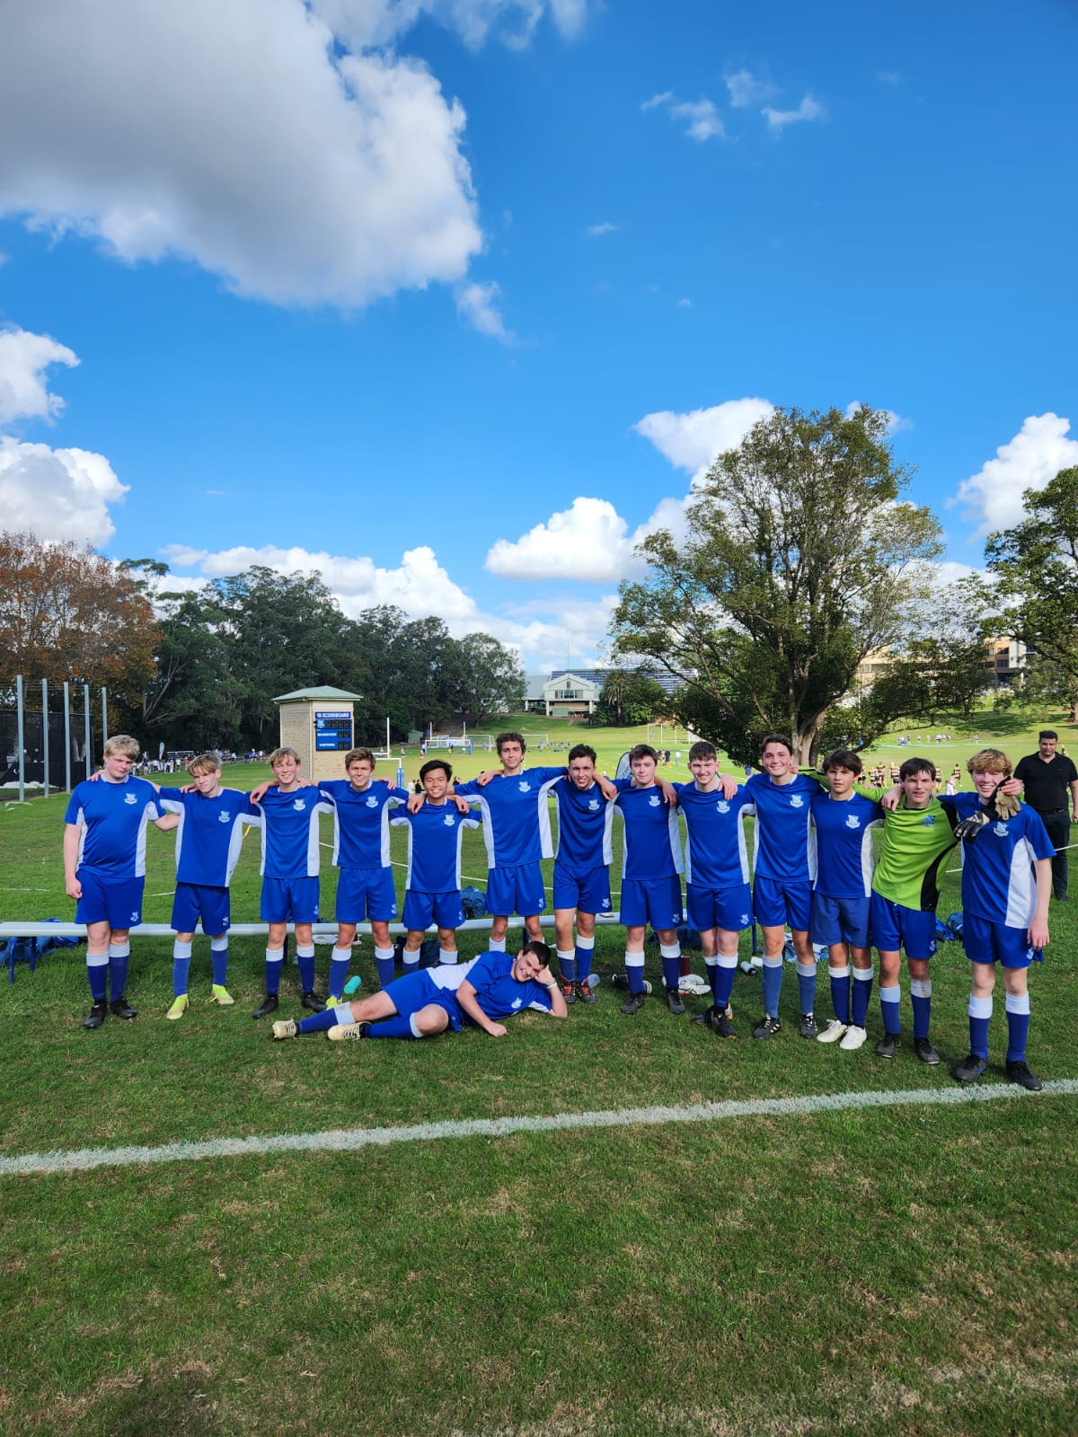
7th Match Report: Coach Maximus Joosse
Although the scoreboard reflected a 2-1 loss, this game marked a significant step forward for the team. Facing a strong opponent who had previously defeated us 5-0, the boys showcased remarkable progress with a performance to be proud of. The opposition scored once in each half, but our team remained composed, organized, and determined throughout. Late in the second half, our efforts were rewarded when Brandon Armstrong delivered a precise cross into the box, confidently finished by Lachlan Ferris to reduce the deficit to 2-1. Morale stayed high, with the boys displaying genuine belief and hunger. Their teamwork, energy, and relentless desire to compete until the final whistle made this one of our best performances of the season. We are very proud of the effort, this result clearly demonstrates how far the team has come.

