

Riverview Football Program - Match reports Saturday 21st, June

Year 7
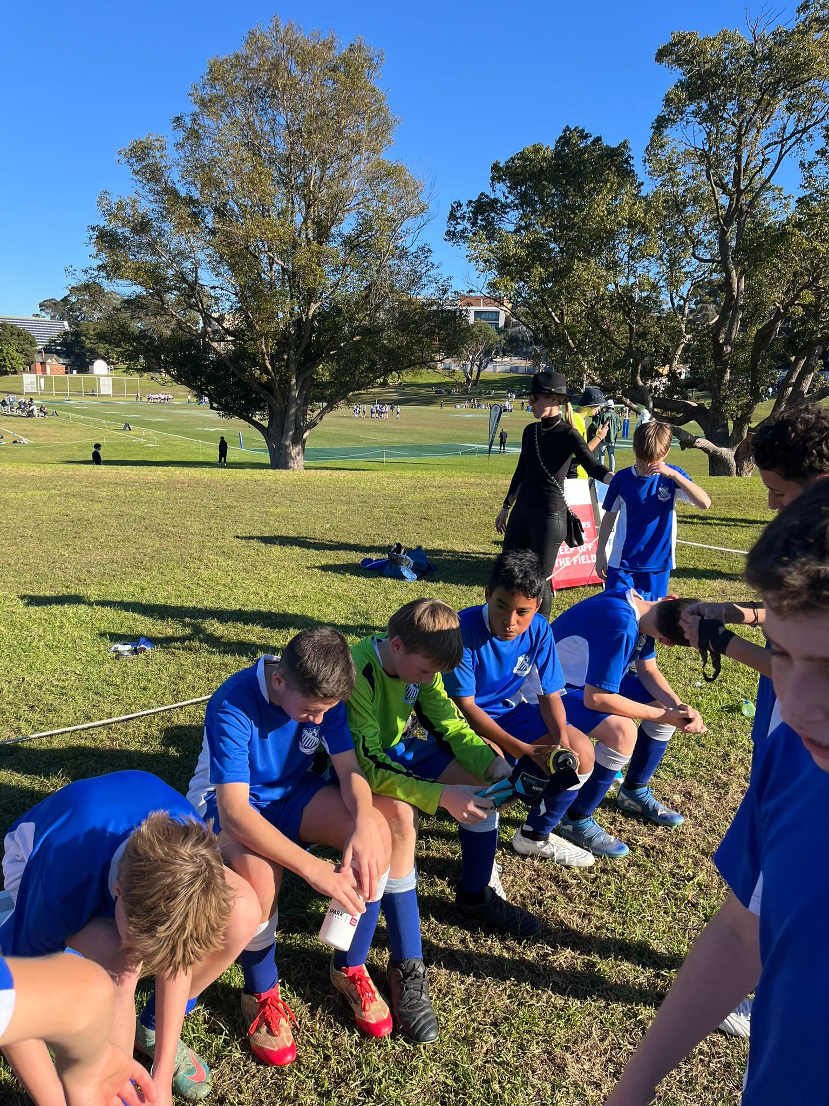
11A’s Match report: Coach Zac Kalogerou
In a typically tough fixture against Newington 13A, Riverview 13A showed early resilience despite conceding in the opening minutes due to a transition error. The response was outstanding, as Jakob Stalley and Emmanuel Charry-Vergara led a spirited comeback with three classy goals, turning the game on its head to take a 3-1 lead. The first half was an open, end-to-end affair, with both teams displaying impressive attacking intent but lapsing defensively. Newington capitalised with two late goals to level it 3-3 at halftime. The second half saw momentum swing Newington’s way. Despite some bright passages of play from Riverview, Newington controlled possession and punished any loose moments, scoring four unanswered goals to secure a 7-3 win. While the result didn’t go our way, the first-half fightback and glimpses of attacking brilliance showed the group’s potential. The experience will only make the team stronger going forward.
13B’s Match Report (no photo available): Coach Domenico Garreffa
In a fiercely contested match, Riverview 13Bs fell 4-1 to Newington College in a game that was closer than the scoreline suggests. The first half saw Riverview dominate defensively, limiting Newington to just a single shot, which unfortunately found the back of the net. After halftime, Riverview came out a little slow, conceding early, but the boys showed impressive resilience. They rallied with strong defensive organization and numbers around the ball in possession, stifling Newington’s attacking play for long stretches. Their persistence paid off when Austin’s relentless pressure won the ball high up the pitch, allowing Javier to calmly slot home a well-deserved goal. Despite the loss, the Riverview boys showed great character and commitment throughout, demonstrating strong team spirit and work rate. There’s plenty to build on heading into future matches.
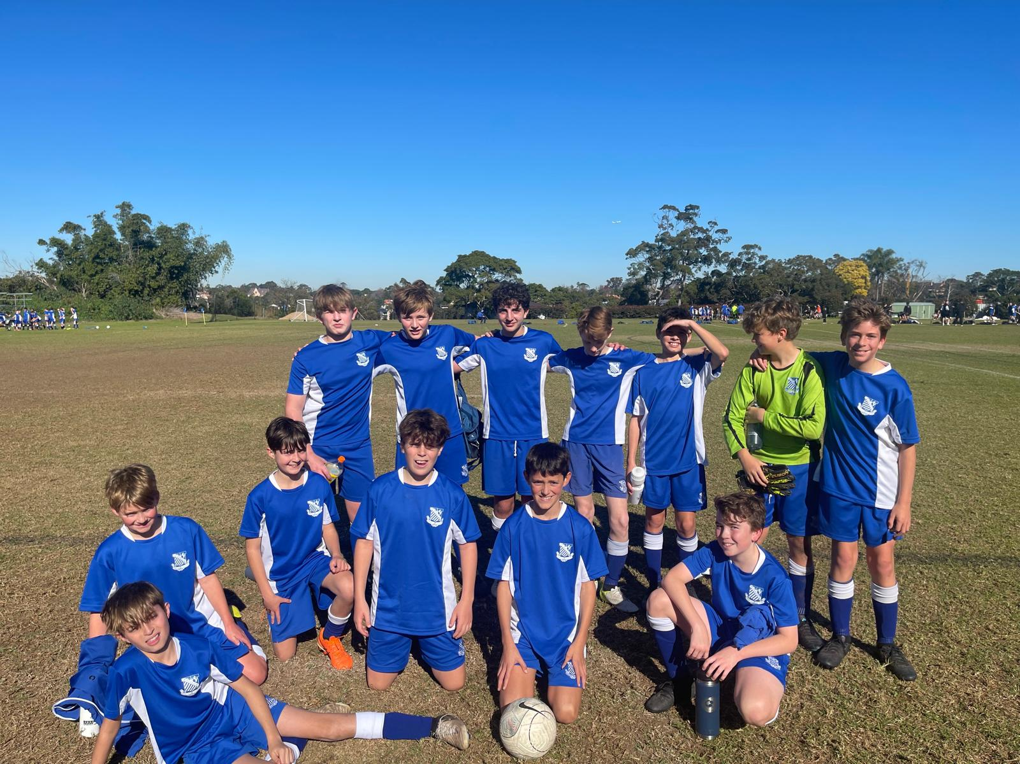
13C’s Match Report: Coach Tom Kalogerou
Riverview 13C’s went down 5–0 to a strong Newington outfit on Saturday, who showed their technical strength and individual skill across the park. After conceding early, Riverview responded with determination and fight, pressing well and creating chances, led by the tireless work of Noah Gatt in the final third. The midfield battled hard to regain control, with Ollie Thistlewood leading the group and breaking up attacks with relentless effort. In defence, a no-nonsense approach saw Riverview frustrate the opposition, especially through Matteo Scardilli, who defended bravely and initiated positive play by progressing the ball into attacking areas. The boys were still in it at 1–0 down at halftime and showed immense heart. However, Newington’s quality shone through in the second half, with some unstoppable finishes. Despite the scoreline, it was a proud performance full of effort and intent. The team now looks forward to a well-earned break before returning next term.

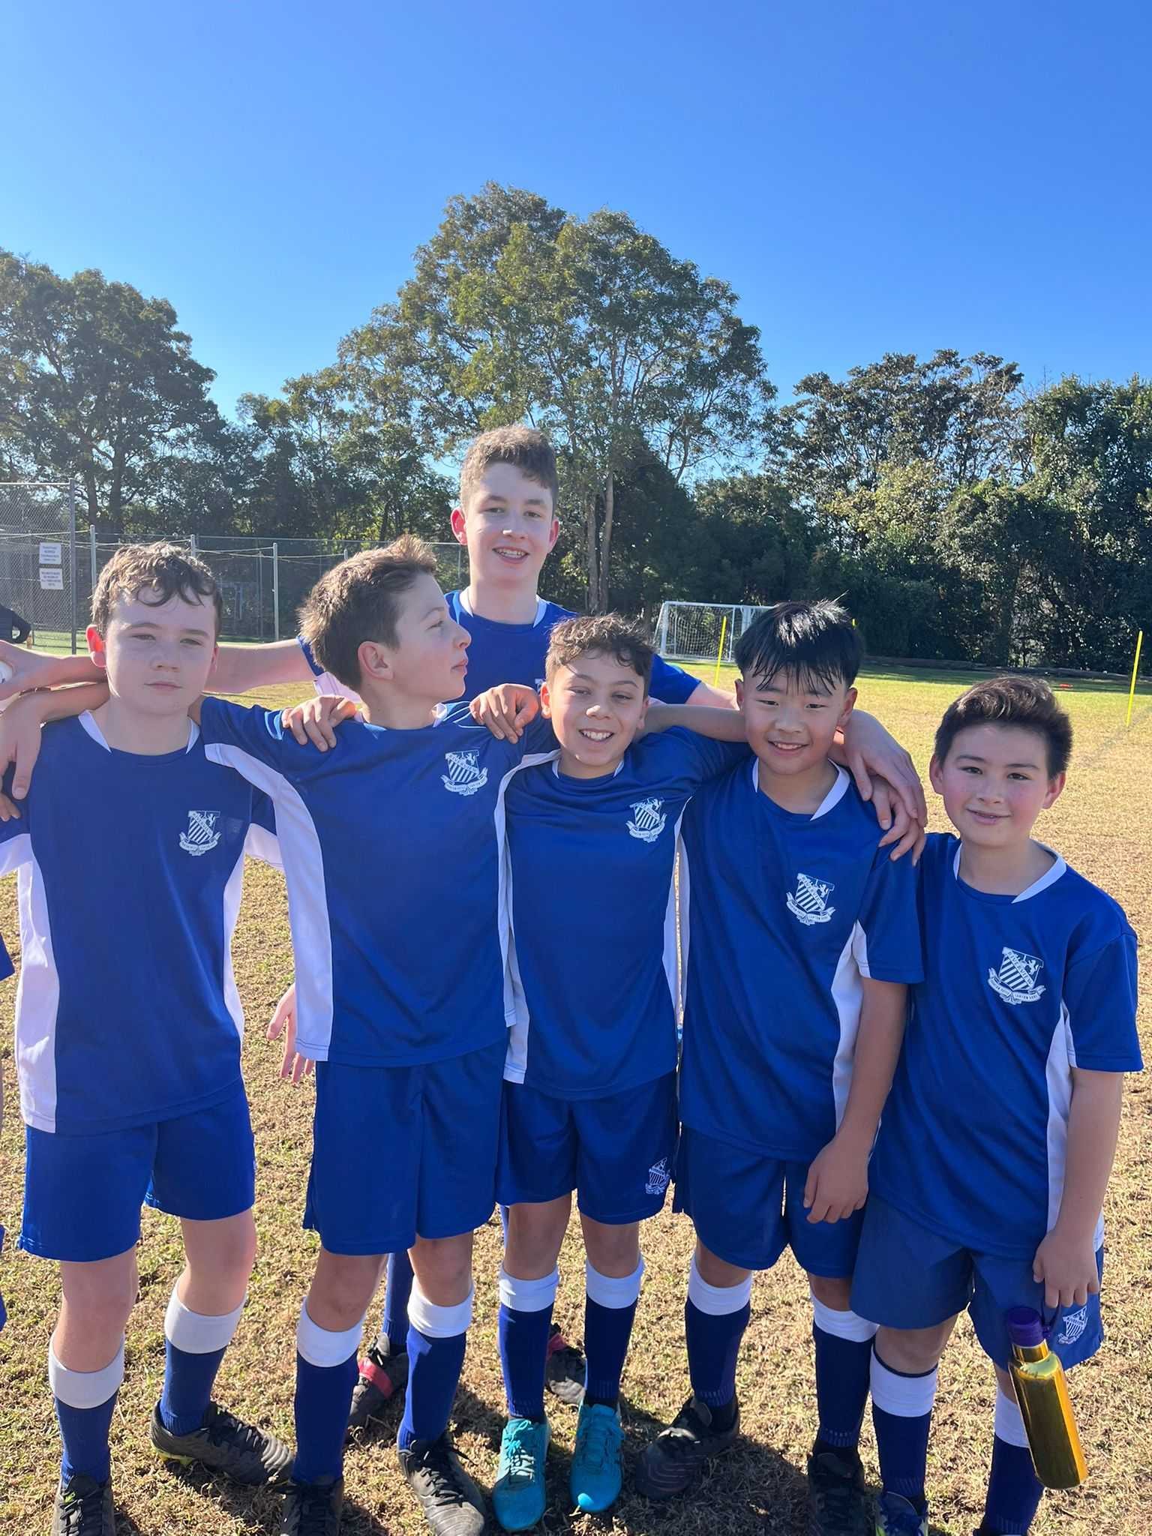
13D’s Match Report: Coach Marcus Kulukovski
The Riverview 13D's played Newington College over the weekend, unfortunately suffering a 7-0 loss. The boys showed great determination early in the game, going stride for stride with a superior opposition and matching their intensity. However, the first goal came from our own mistake, and we struggled to recover from that setback as Newington quickly gained momentum. The 13D's showed great fight and were able to play through the opposition from our goal kicks on numerous occasions. Notable performances came from Haotong Max who showed persistence and effort to win the ball throughout the game. Overall, a solid effort by the 13D's who will certainly look to bounce back in their next game.

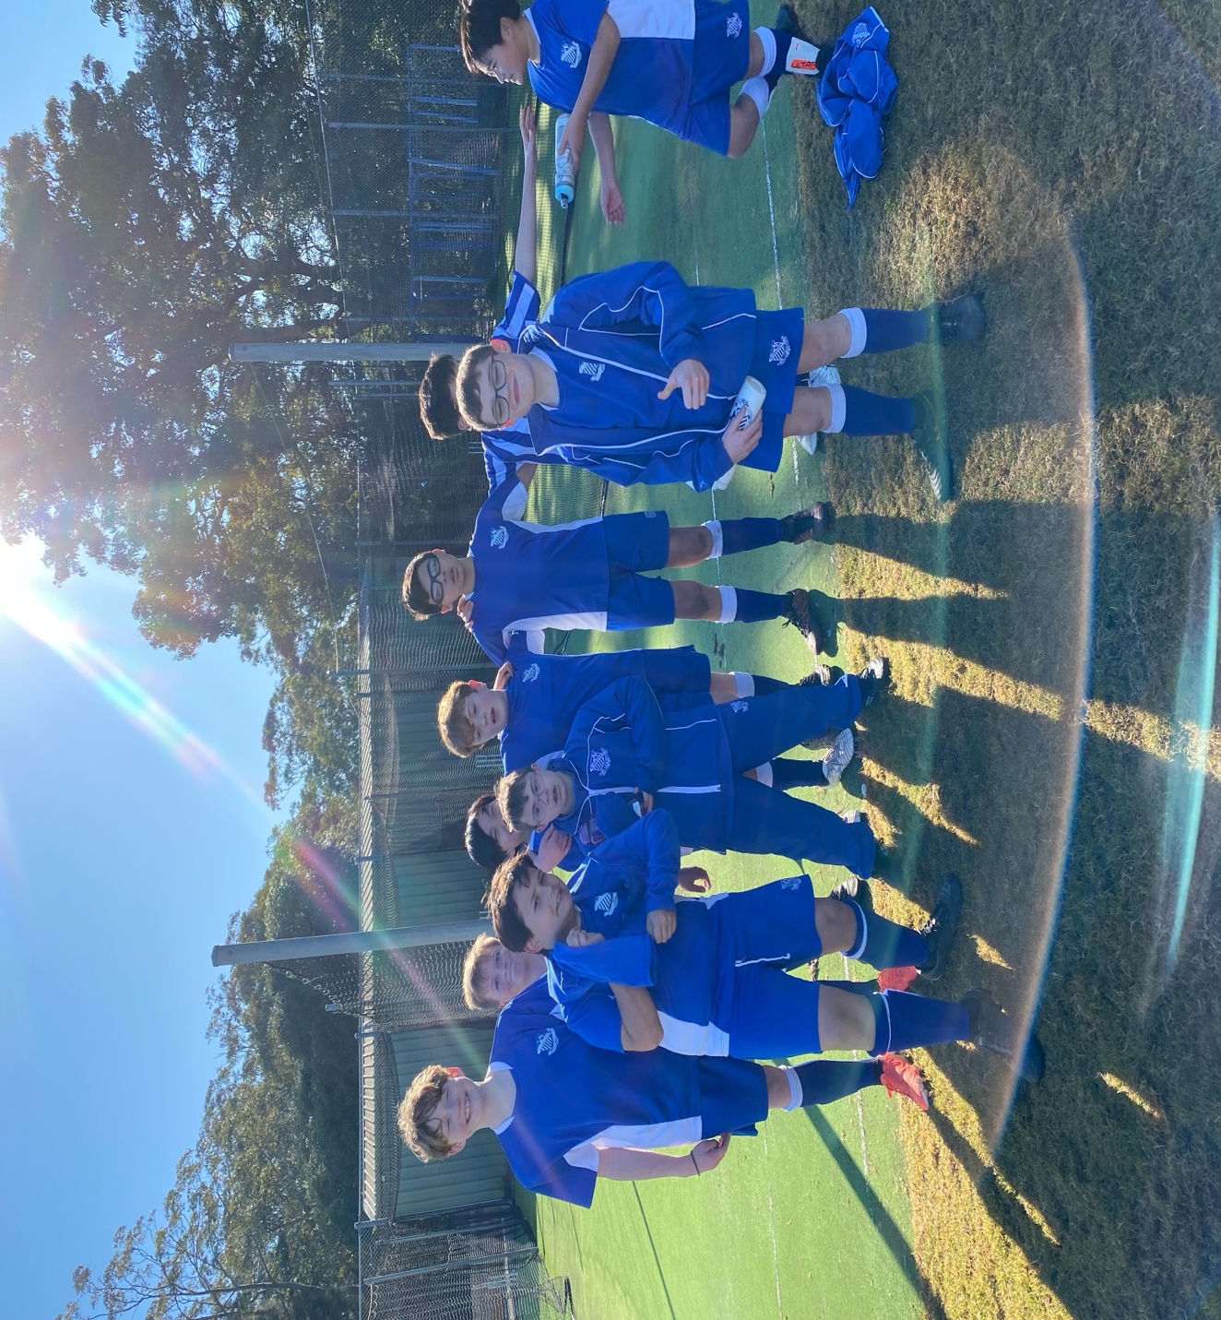
13E’s Match Report: Coach Charlotte Afeaki
It was a chilly start to the morning but 13Es were soon awake defending well under high pressure from Newington early on. A lot of traffic came the way of the defence line but both Angus and Lachie did an outstanding job of putting pressure on their forwards. Captain Michael as always led from the front with great communication and organization of the team. Newington continued their barrage of attempts in the second half but Jayden bravely went in goals and did some excellent goal kicks. The final score 10 – 0 did not reflect the hard-fought struggle from our boys. We look forward to our next chance to showcase our attack.

Year 8
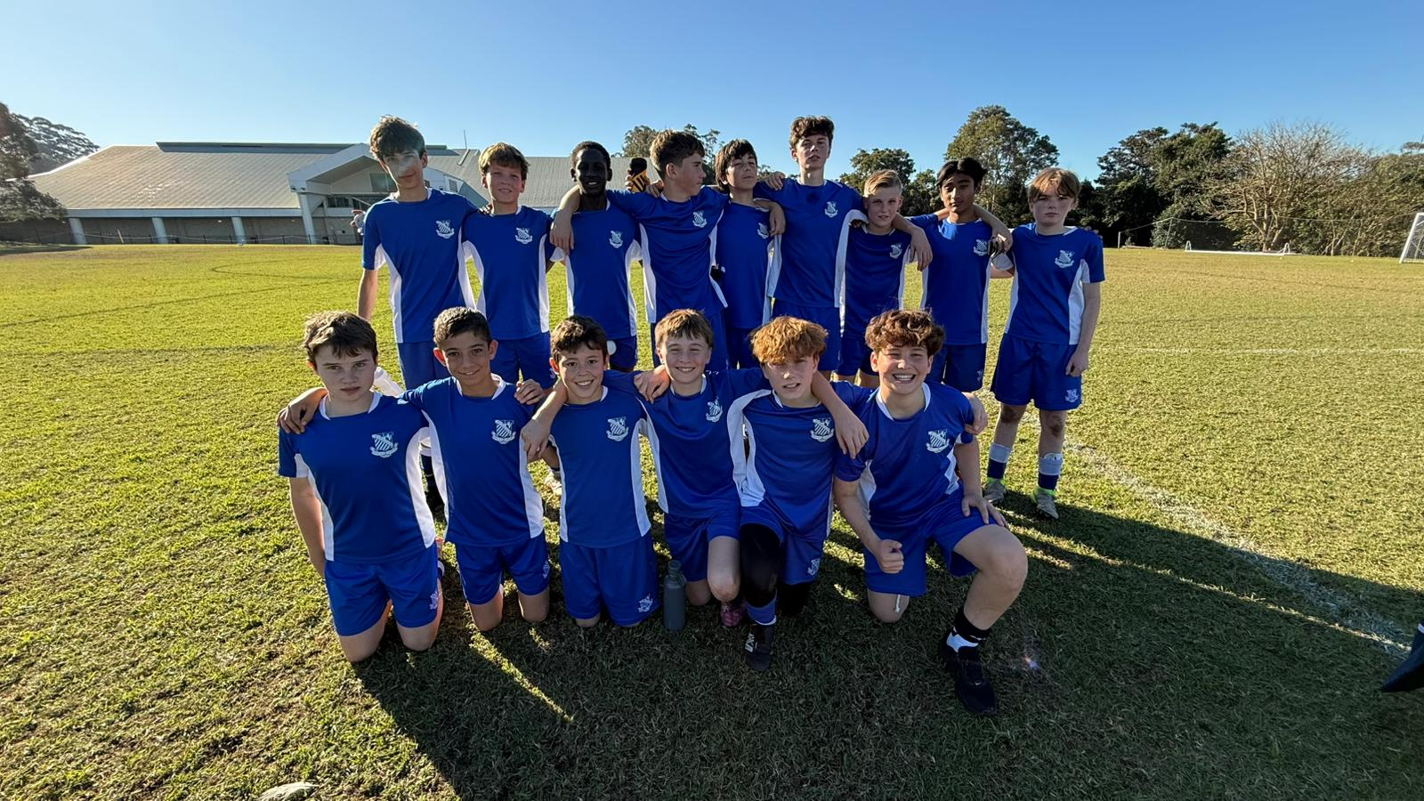
14A’s Match Report: Coach Roberto Fausti
Riverview College began the match with great determination, dominating the first half and coming close to scoring on several occasions. Hugo and James R. narrowly missed the target, while the Newington goalkeeper made two outstanding saves to keep the score level. Just before halftime, a misplaced pass allowed Newington to take the lead against the run of play. Early in the second half, Newington scored again with a powerful strike from distance that flew into the top corner, giving goalkeeper William C. no chance. Riverview responded well, with James Russel finishing brilliantly after a clever through ball to bring the score to 2–1. Our team pushed hard for the equaliser, creating multiple chances, but the Newington keeper continued to stand out. Two late defensive errors allowed Newington to extend their lead, ending the game 4–1. Despite the result, there were many positives: the team played with unity, confidence, and quality. Noah, who controlled the midfield with composure and energy, was named Player of the Match. We’ll carry this progress into Term 3 and return stronger.

14B’s Match Report (no photo available): Coach Lachlan Easdown

The stage was set for the 14Bs as they took to the pitch against one of the strongest sides of recent years in Newington College. Following kick-off, it was clear Newington’s skill on the ball and physicality in the midfield was going to be a difficult task for us to breakdown. Much of the pre-match tactics centered around matching the highline we predicted Newington would bring with an offensively oriented setup ourselves. Across the 1st 15 minutes or so as we adapted to Newington’s aggressive play style, we began to take back a higher degree of possession and more importantly, gave ourselves more opportunities to be threatening in the final 3rd. This came about because of better execution of a key focus we have had recently on replacing extra touches on the ball with movement after the pass, dragging opposition defence with us to give the opportunity to our teammates to fill the gap. Max, Alonso, Ben and Will were key to executing this shift. Once again, shoutout to Will Hall - although he had little of the ball today, he gave everything in this capacity to make forward runs and give us space in the opposition's half, exemplifying how we can reduce unnecessary touches with movement off the ball. Another shift which helped us re-assert our dominance on the ball and a more offensive structure was to use width to our advantage, helping us play around the physicality Newington brought, especially in the midfield. This extended the perimeter within which Newington looked to attack and lead to gaps opening for our midfielders Sam, Lachie, Alonzo and Max to run into when receiving from the fullbacks and wingers.

Across the 1st half, although Newington’s highline and physicality, at times was suffocating on our ability to play the ball out, one of the hallmarks of why this game was our best of the season was the tenacity we showed and commitment to our midweek work on maintaining a compact yet dynamic shape in defence. This ultimately led to Newington having very few shots at across the first half despite holding a highline in possession. Massive shoutout to Max Tevanian, today’s MOTM, who was an absolute warrior all match, setting the bar extremely high for his teammates with his unrelenting work rate, and strength in tackles against players much bigger than him. The biggest highlight of today came in the form of 3 sensational goals from Ben, Max and James. Ben and Max both produced sensational strikes to finish off some well worked team efforts, and James scored one of the goals of the season from a free kick a number of meters off halfway, managing to swerve it from right to left, bamboozling the Newington keeper, as the ball dipped at the last moment under the crossbar. Unfortunately, with the substitutions of Alonzo and our goal of the season contender, James, for the A’s game, Newington were able to win a few more midfield duels leading to less confidence committing numbers forward.

In the end the 3 goal cushion was chewed up with Newington finding a few long-range efforts successful, and the result standing at a 3-3 draw.
Very proud of the efforts today, there are many positives to take into our final rounds of the GPS campaign next term as we look to capitalise on this momentum and continue our personal growth throughout the remainder of the season.
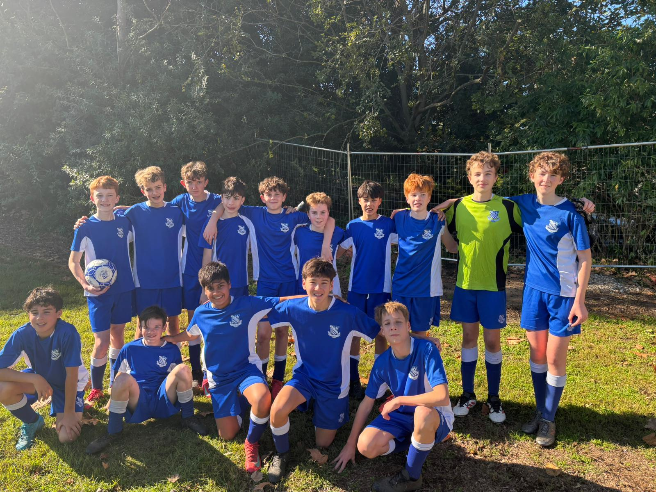

14C’s Match Report: Coach Mark Musumeci
Riverview started the match with strong intent and created an early chance through a well-taken free kick from Tom Sadaat on the top left of the penalty box. His delivery found Pax Baker, who rose high and powered a header towards goal. Although it didn’t find the back of the net, it was a promising play that showed great attacking intent. Despite the strong start, Newington gradually gained momentum and took control of the match. The Riverview defence was under constant pressure, and the team struggled to clear the ball and transition into attack effectively. That said, Will Carney put in a solid performance at centre back, showing composure under pressure, while Luke Dart was dependable on the wing, and Julian Makita worked relentlessly in central midfield, making several important interventions. A key takeaway from this match is the need to transition more quickly out of defence. As soon as possession is won, players must look to move out of the defensive half with urgency to relieve pressure and create attacking opportunities. It is also an important ability to get free from defenders, as off the ball movement is crucial to support transitions and build play through the midfield.
With these takeaways in mind the last training for the term will focus on possession-based games to develop the quick transitions and the ability to get free from defenders.
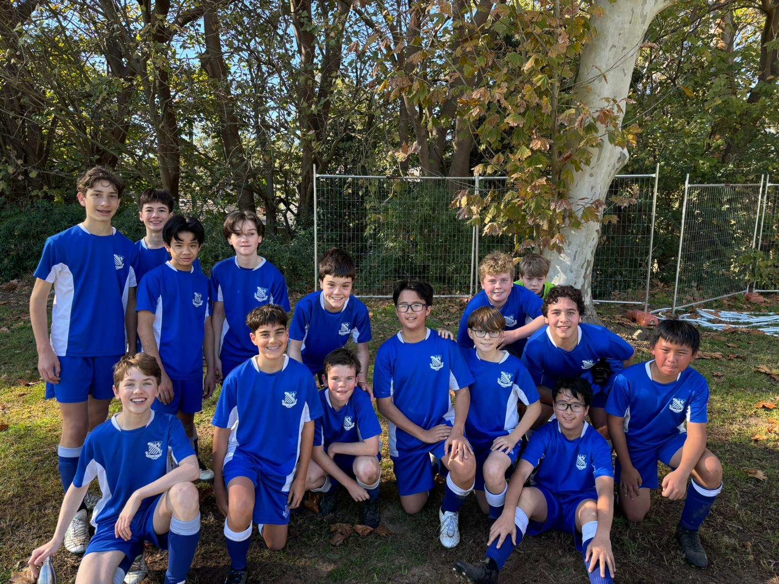

14D’s Match Report: Coach Mark Musumeci
Riverview put in a passionate performance against a strong Newington side, ultimately falling 1-4. Despite the result, the team showed great spirit and determination throughout the match. A highlight of the game was an excellent goal by Jason Herrera-Hu, who finished confidently to give Riverview a well-deserved moment to celebrate. Nicholas Mian also had a strong performance, contributing to the defence with consistent effort and smart decision-making. By working on playing out from goal kicks, the team can focus on pushing play into the attacking half, while also consistently moving the defensive line higher to avoid becoming trapped in their own half.
Although the scoreline didn’t reflect the team’s effort, the boys should be proud of the fight they put up against Newington. The focus moving forward will be on building confidence in possession and maintaining intensity across the full match.
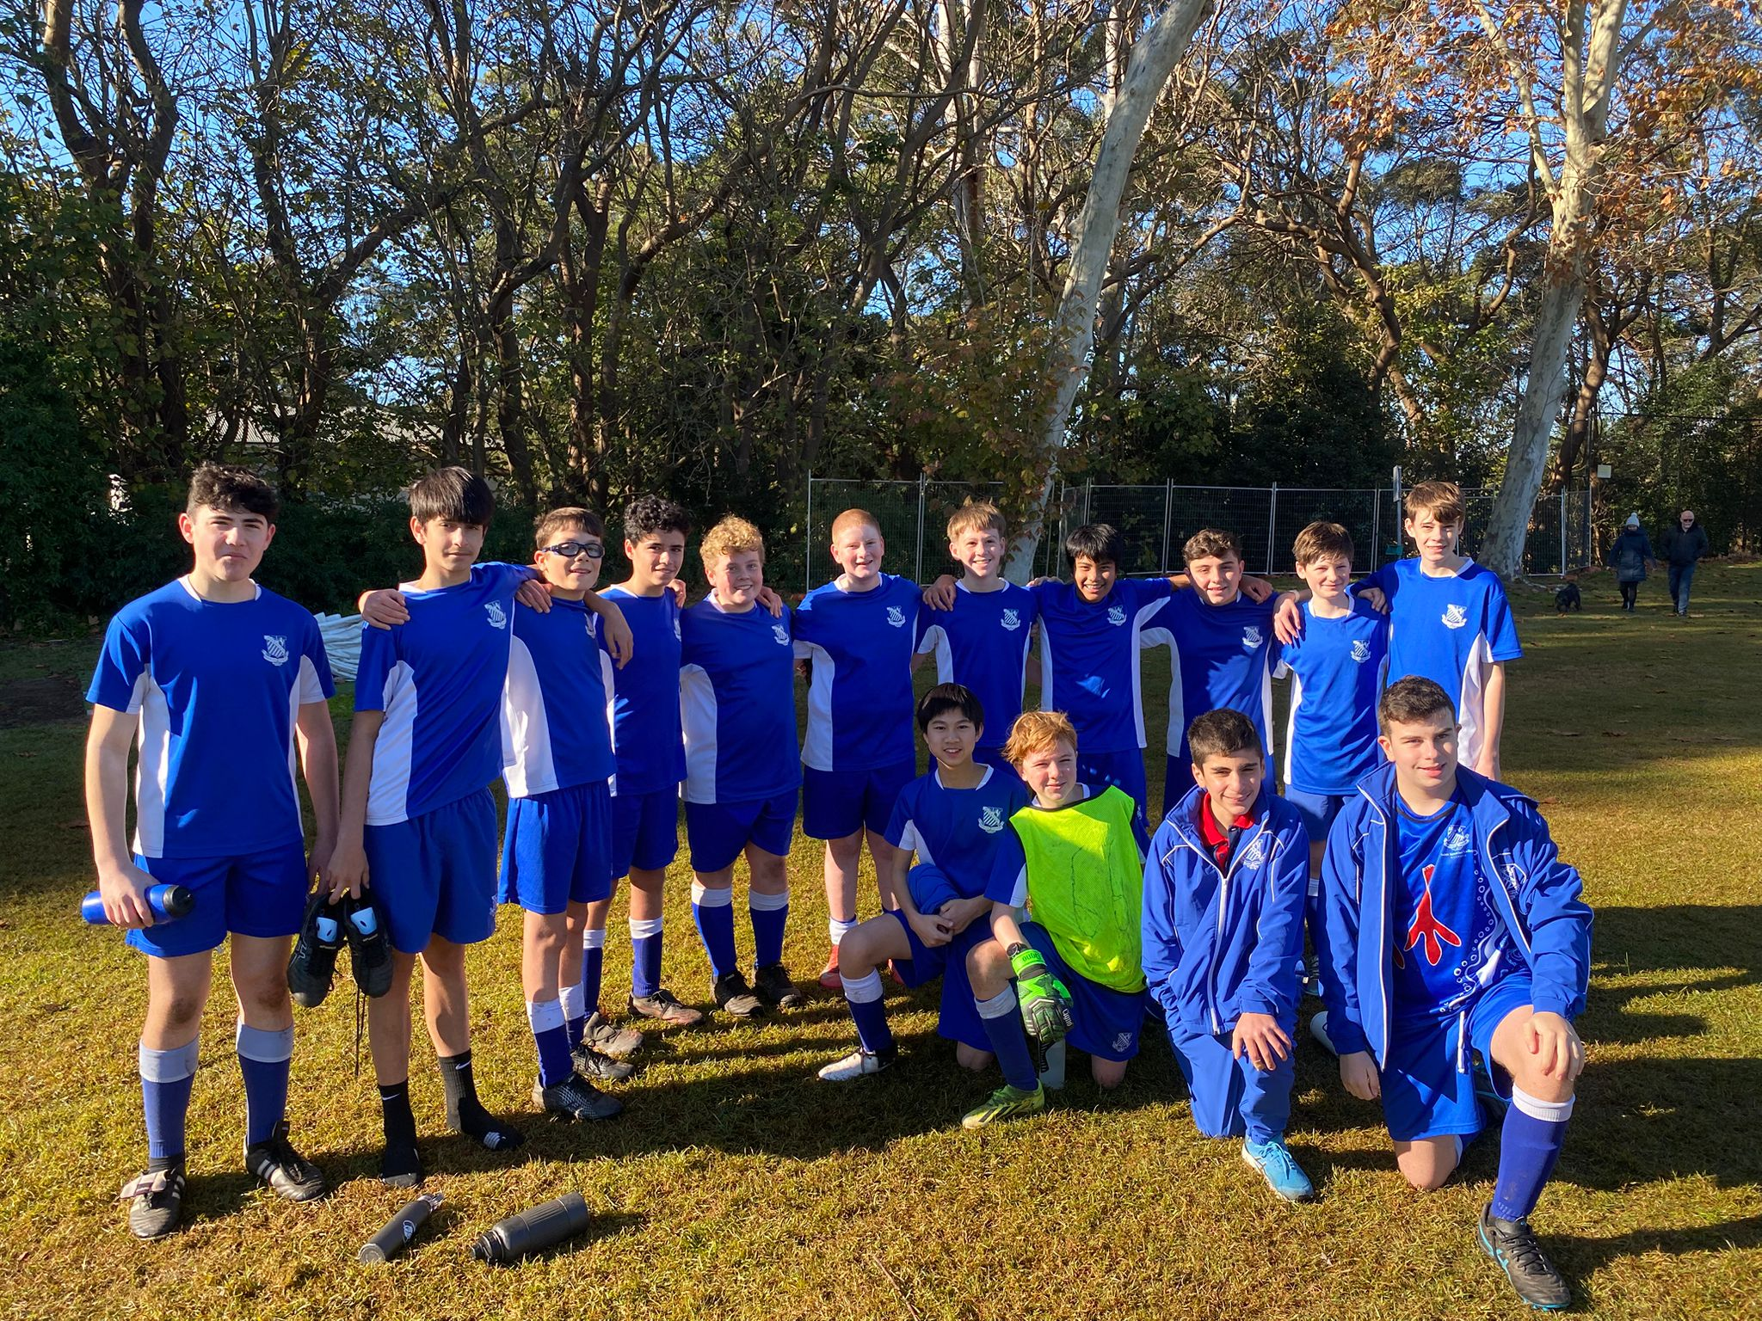

14E’s Match Report: Coach Matthew Chung
This week, the Riverview 14E’s faced a tough test against a strong Newington side, ultimately going down 8-1. Despite the scoreline, there were patches of promising play and individual moments of quality. A shift to a 4-3-3 formation saw the captain Oliver Lee move into the number 6 role, where he helped control the midfield alongside Mac and Gabe. That midfield trio began to create more opportunities going forward, and it paid off with our lone goal: a well-weighted through ball from Gabe found striker Angus Stanic, who beat the centre back for pace and drilled a powerful low shot into the bottom corner. On top of that, Freddie and Max showed great resilience from the back, working tirelessly to stop Newington’s barrage of attacks. While the result was disappointing, the switch in shape brought more structure, and the team continued to fight throughout. The team will be looking to bounce back next week with a stronger showing.

Year 9

15A’s Match Report (no photo available): Coach Travis Cooper
The U15As suffered a tough 4–2 loss against a strong Newington side in a tightly contested match that could have gone either way. Newington struck early, putting the boys on the back foot, but the team responded well. Louie levelled the score with a composed finish, and soon after, nodded home a well-taken header to give the team a 2–1 lead. Just before the break, Newington found an equaliser to make it 2–2 at halftime. The boys came out firing in the second half and created several promising chances, showing great attacking intent and energy. Unfortunately, they couldn’t capitalise on those opportunities. With just ten minutes to go, Newington edged in front from a corner, then added another shortly after to seal the result. While the 4–2 scoreline didn’t reflect the closeness of the contest, there were plenty of positives to take.

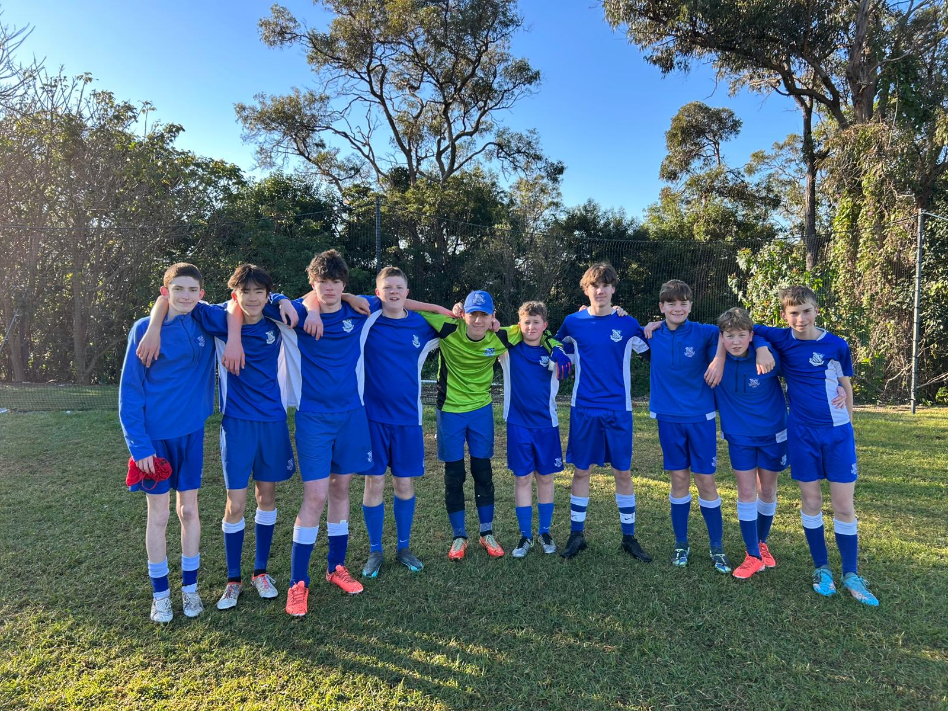
15B’s Match Report: Coach Jonathan Codemo
The boys showed immense character and determination in a thrilling 2-2 draw with Newington, battling from start to finish with hunger and heart. The match began with high intensity, with both teams being dangerous in attack. As the game continued, Xavier found himself on the edge of the box where he was tackled, providing Riverview with a goal-scoring opportunity. Olivier stepped up for the free kick and delivered a beautifully struck free kick, curling it past the wall and into the bottom left corner to give the boys a 1-0 lead in the first half. Coming into halftime, the boys were ready to defend with their lives to secure the win; however, after a deadly attack from Newington, the game was level at 1-1.

Despite conceding an equaliser, the boys didn’t drop their heads. Instead, they pushed forward with purpose, giving everything they had. As the game continued, the boys were rewarded with another free kick, this one being 30 yards out with Patrick stepping up to take. After striking the ball with precision and accuracy, he scored his free kick, giving the boys a 2-1 lead. As the time ticked down, the boys gave it their all the win the game. Our defence, led by Freddie, Ned, and Riley, all put in some amazing tackles to stop Newington’s attack. In particular, Freddie’s slide tackle towards the end of the game highlighted the brotherhood and determination the boys had. However, Newington struck just before full time to equalise the game, with the game ending in a 2-2 draw. All credit to the boys who gave it their all and never gave up. Special mention goes to the man of the match, Max, who played like prime Buffon in goals, displaying a masterclass performance.
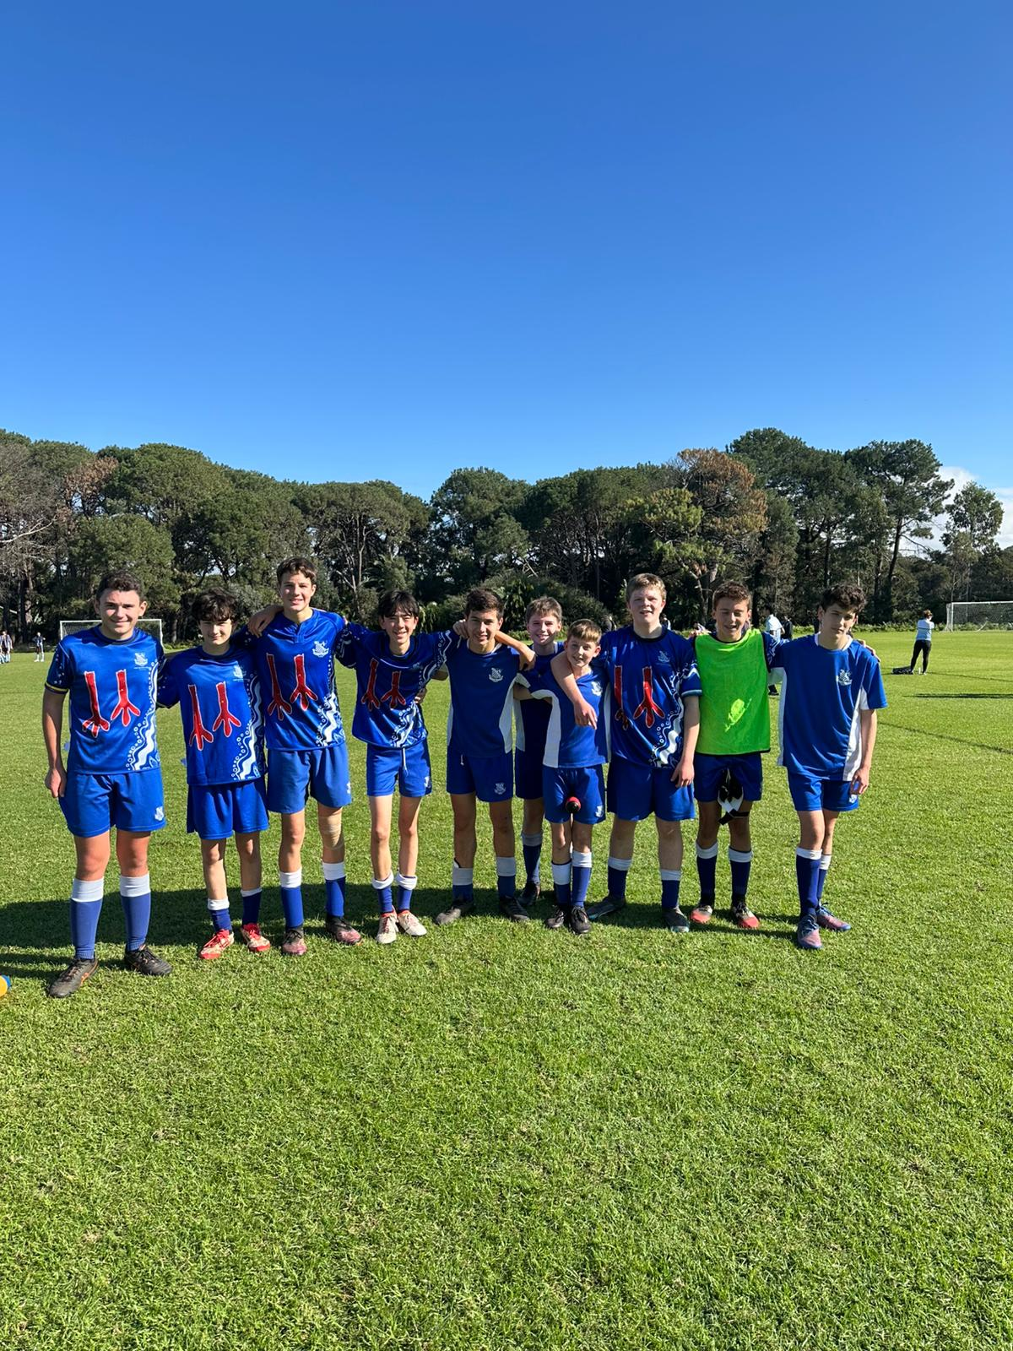
15C’s Match Report: Coach Josh Engelman
The 15Cs faced Newington at Riverview in a tightly contested match that ended in a narrow
2-1 defeat. From the outset, both teams traded attacking blows, with Riverview controlling possession in key moments and asking serious questions of the Newington defence. Patrick’s deliveries from set pieces kept the pressure on, but despite multiple chances, the breakthrough proved elusive. Newington struck first through a quick move down the middle, but the boys responded with
composure and continued to play with intent. Their persistence was rewarded when Jack Mulveney found the net, calmly finishing after a sharp attacking move.With the scores level, the match remained open, and both sides pushed for a winner. Unfortunately, a late lapse allowed Newington to snatch a second goal on the break. Despite the result, the boys showed strong character and discipline. With continued effort and belief, results will start to swing their way.
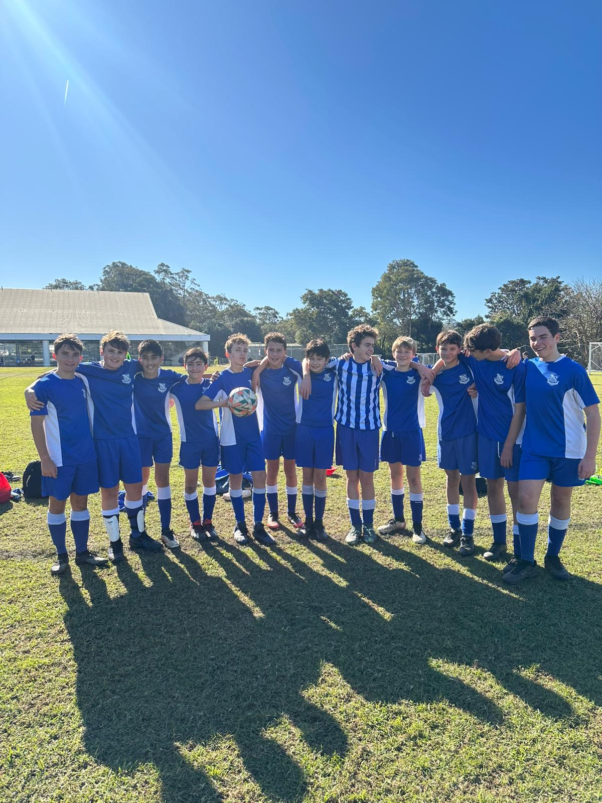
15D’s Match Report: Coach Josh Engelman
The 15Ds would have their first home game of the season facing Newington College. Determined to show growth since their pre-season defeat to the same side. From the outset, Riverview played with purpose, dominating large passages of play and forcing Grammar to defend deep. The boys created several good chances early on, linking well through midfield
and testing the opposition keeper. Despite Riverview’s attacking pressure, it was Grammar who found the opener against the run of play. The boys didn’t let it rattle them—Patrick and Hopper continued to drive forward,
while James Wyile was a constant threat down the right. Riverview’s defence held strong for much of the match, with Lachy pulling off some important
saves to keep the team in it. However, as the game wore on, Grammar took advantage ofn late opportunities to extend their lead.
The final scoreline didn’t reflect the performance. With this level of effort, the results will come.
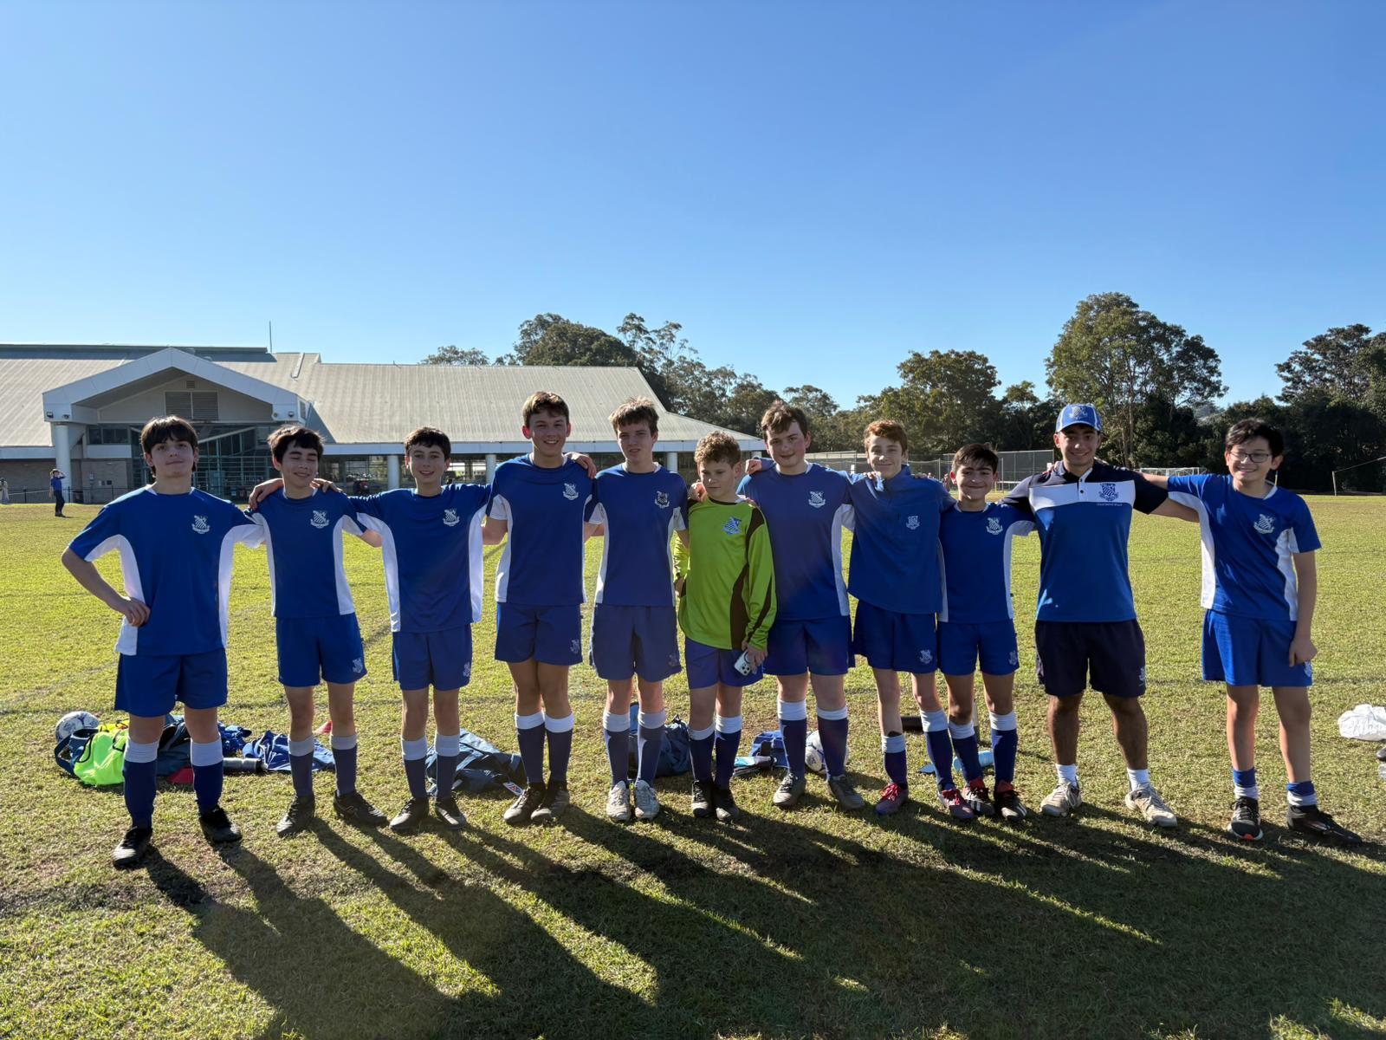
15E’s Match Report: Coach Jospeh Salameh
The 15Es played a very interesting game this Saturday against Sydney boys high. The first half was largely a struggle, we seemed to play defence for majority of the half and couldn't put together an attack of our own. Jules held it down in goals to keep the game in check however it was 4-0 at the end of the first half. At half time the game changed, the boys came out of an inspired half time talk with a new motivation and belief in themselves to do better. Eddie moved into goals and continued Jules amazing work, making many good saves. Eddie T worked very hard in defence playing physical, while Xander and Rhys also played very hard. All the midfields were working very hard in the second half and ultimately Xavier was able to get an incredible goal!! The boys were very happy and props to Xavier for working so hard through the game. Joey was playing very hard as well as Will who nearly got a goal too. The boys can continue this second half energy into the following term and build towards a win.

Year 10

16A’s Match Report (no photo available): Coach Nicholas Kalogerou

'After a tough game last week against Grammar, the 16A View boys were looking to bounce back against Riverview’s long standing football rival, Newington College. This week was a little different as well because we had a few boys away on Country placement. Nevertheless, we were able to field a very strong team with some help from a few of the boys in the B’s who have been playing unbelievably well recently. The started the game well and took the game to Newington straight away. Alex, Stack and Harry were dominating the midfield and giving some great ball to both Marcus’ and Jules up front.
Our back 4 consisting of Austin, Xavier, Drew, and Sam were rock solid and did a great job at limiting the Newington attacking players to minimal chances in the opening part of the game. Some of our best chances of the game were coming from beautiful midfield combinations between Alex, Stack and Harry and then nicely slotted through balls to both Marcus’ and Jules. The boys were able to play right through the heart of Newington’s team, which was great. Unfortunately, the ball wouldn’t sit for one of our forward players to be able to get a clear shot on goal. Although the boys dominated the first part of the game, it was Newington who would take the lead through a penalty in the back end of the first half. JP dived the correct way, but the ball was slotted perfectly in the bottom corner by the Newington player.

0-1 Newington

Lucas slotted seamlessly into the midfield to help continue View’s dominance in that area of the field, winning some vital duels and distributing beautifully to our forwards players. Well done, Lucas! The View boys did get their reward for a great half of football, just before half time. After winning a free kick, Stack’s delivery was cleared by a Newington defender, but Finn struck the ball cleanly right into the bottom left corner of the goal to level the score. What a strike, Finn!

HT 1-1

The second half was a tight battle with both sides doing everything they could to try and find their second goal. Newington had various waves of attacks, but Austin, Charlie, Drew, Xavier, and JP all stood strong. Special mention to JP who made some excellent saves to keep a clean sheet in the second half.
Stacky and Jules were looking dangerous on their various wings but unfortunately, we couldn't find the winner. Like I mentioned at the start of this report, I was delighted with the effort and performance from the boys particularly as it was a unique week with country placements. Credit to the boys for sticking together!

FT 1-1

Thank you again to all the boys from the B’s who played for the A’s this week, Jules, JP, Austin, Lucas, Marcus, Charlie, and Finn, you were all fantastic and showed you’re all at that level. Thank you also to all the parents who transported the boys to the game and supported from the sidelines. I hope everyone enjoyed the rest of their weekend! Boys, enjoy your placement week next week and the upcoming holidays. I’ll see you raring to go in Term 3 to finish off the GPS winter season.

16B’s had a BYE

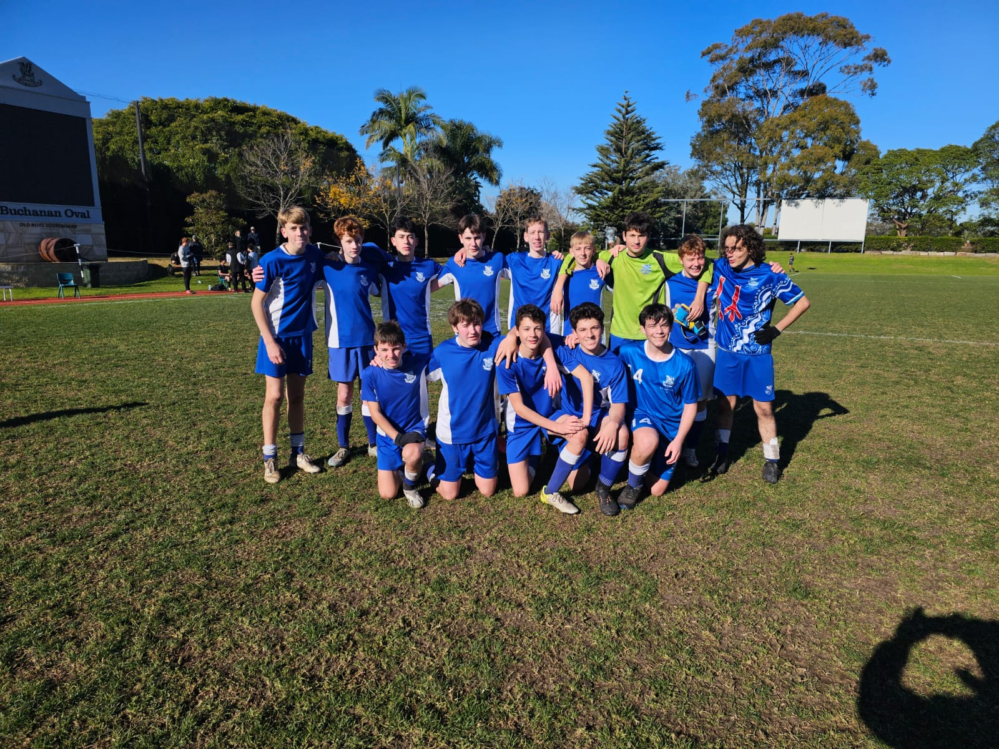
16C’s Match Report: Coach Jacob Stevens
The 16C’s made the away trip to Stanmore on Saturday to take on a challenging Newington College outfit. The boys were bolstered by a few late additions from the B squad. One of their number, Finn Bannan, showed some excellent touches along with dazzling footwork to win an early freekick. The ball was delivered into an uncomfortable area for the keeper forcing him to drop the ball on to Jack Stanic’s head giving us an early lead. Midway through the first half saw one of players brought down in the box giving us an opportunity to double our advantage. Hery Turnball stepped up, initially seeing his shot saved by the keeper although the ball rebounded kindly for him to slot home in a second attempt. The strength of the weekend’s performance was derived from our determination and physicality at the back with all four defenders having an excellent game. Overall, the players were excellent demonstrating continued growth in their passing, movement and communication which culminated in a solid 2-0 win.

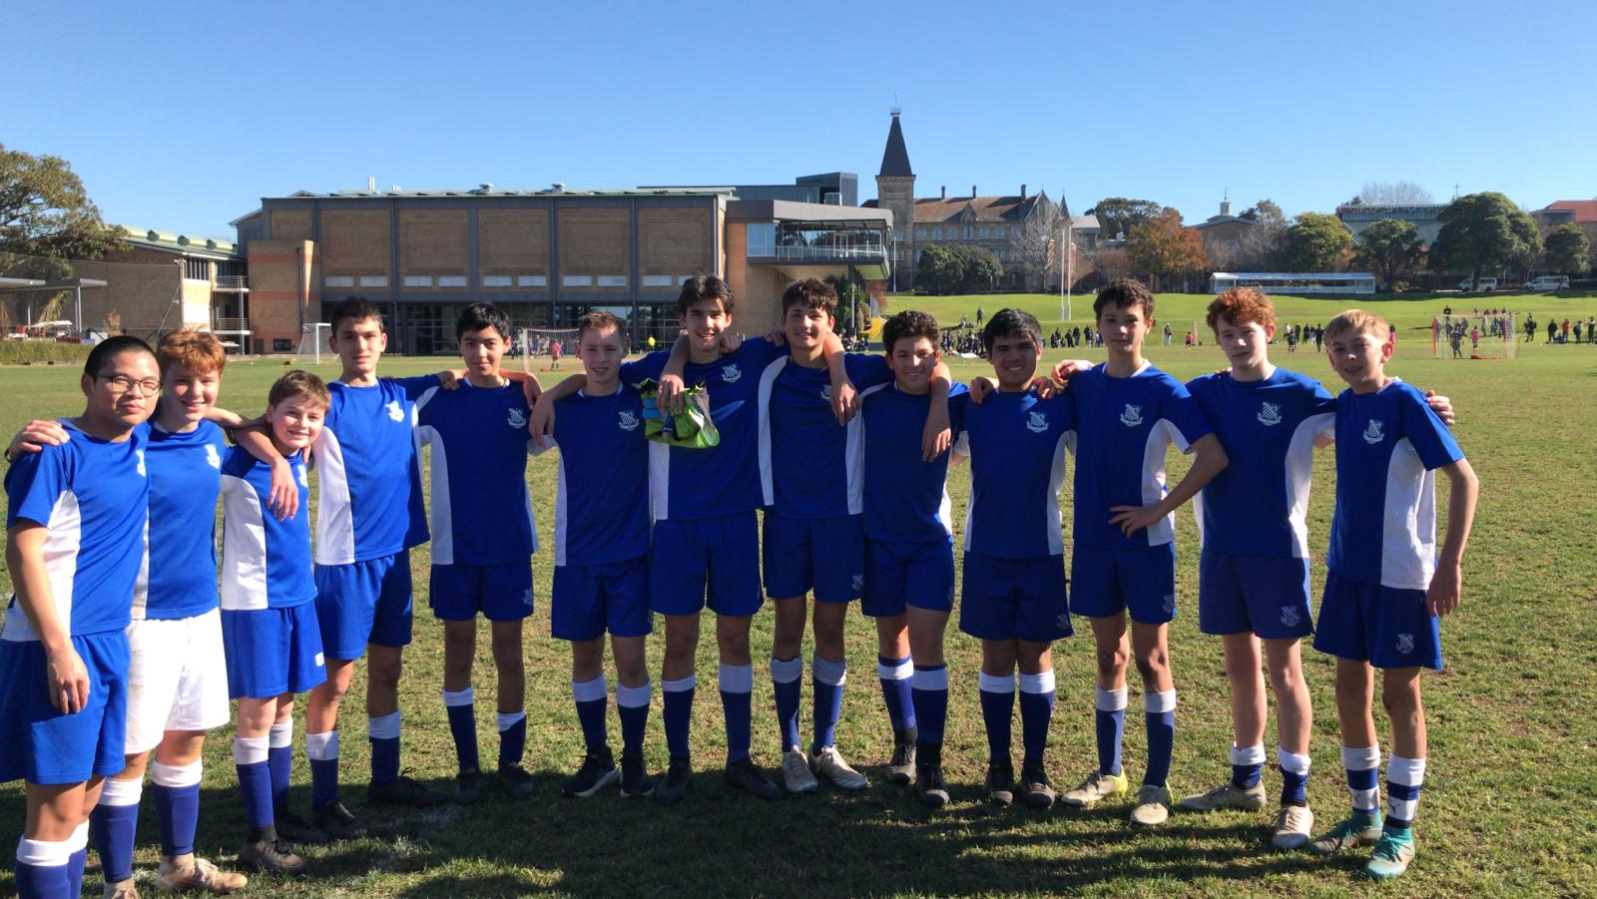
16D’s Match Report: Coach Harold Bonnington
Sometimes the fruits of one’s labour come only after long toil, other times those fruits come instantly and unexpectedly; Saturday’s game was one such example. On a picturesque winter’s day, the 16D’s played Newington at Newington. The first half was played with Riverview’s customary defensive determination and, aside from an opposition kick which was described as ‘a good finish’ and which put the home team ahead by one, Riverview played well across all lines. At the half, the metaphorical magnets were moved and the moment came. Henry Turnbull from the kick off forced the ball forward with his usual attacking resolve. A shot was made and saved but the ball slipped out to the right and was pounced on by Jack Stanic who promptly kicked it into the back of the net. The stunned crowd, small but vociferous, celebrated the first goal of the 16D’s season. The remainder of the half was punctuated by a number of excellent defensive plays particularly from Elliot Solomons at right back as well as Nathan Brooks, Jack Winter and Lachlan Au-Yeung who repelled every foray forward made by the opposition. Jack Charleson, in goal, was impassable and made a number of game-saving saves. Daniel Vassallo made a strong contribution which included a memorable play where, in the second half, he hunted down the ball and began an attacking run. Jacob Bradshaw, towards the end of the game, had a shot on goal which only just missed and Tomas Day played resolutely in both the midfield and defence. The final score read a hard-fought 1-1 draw. Thank you to all the players who filled in for the 16D’s this week, your efforts were greatly appreciated.

OPEN SQUADS

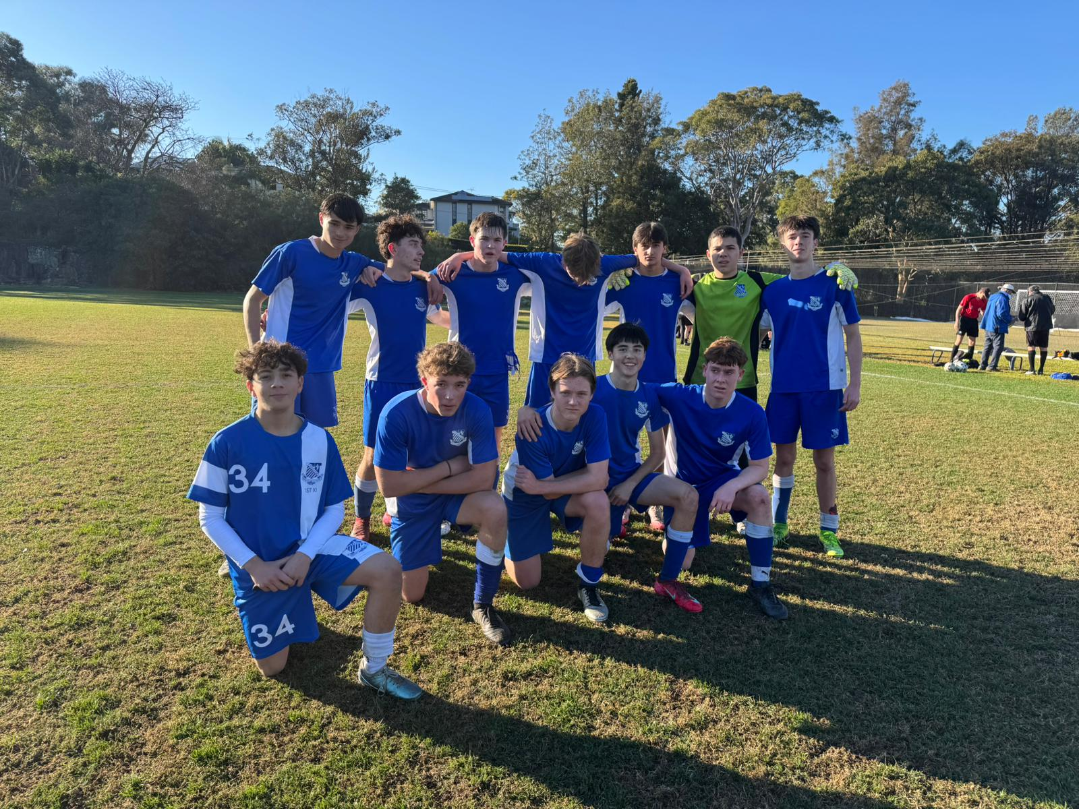
3^{rds} Match Report: Coach Stefano Rossello
Riverview 3rd xi match against Newington resulted in a 1-1 draw. This game concluded the boys 4 game win streak but still continues their undefeated streak, taking it to 5 games without a lost whilst only conceding 2 goals. It was a tough match up for the boys against a strong well-structured Newington side, and this showed as they took an early led after an unfortunate slip up at the back. A-bit of pressure came from Newington following there lead but once the boys were able to control the game there was no doubt of losing. Some well worked passages of play throughout the field gave riverview some good chances but we were unable to convert. This led us to be down at the half 1-0. Halftime talk was about staying focused and to continue pushing to get back into the game and this was exactly done after some great play down the left flank led to a cross in the box which we were able to put away to get us 1-1. After this, riverview had all momentum, getting so close to taking the lead but unfortunately it wasn’t our day in-front of goal. Nonetheless, the boys played their best game all year despite the result, they showed that they are a true team with a strong mentality, they showed their great work ethic and ability to adapt to their opponents and are looking very promising for the 2nd half of the season.
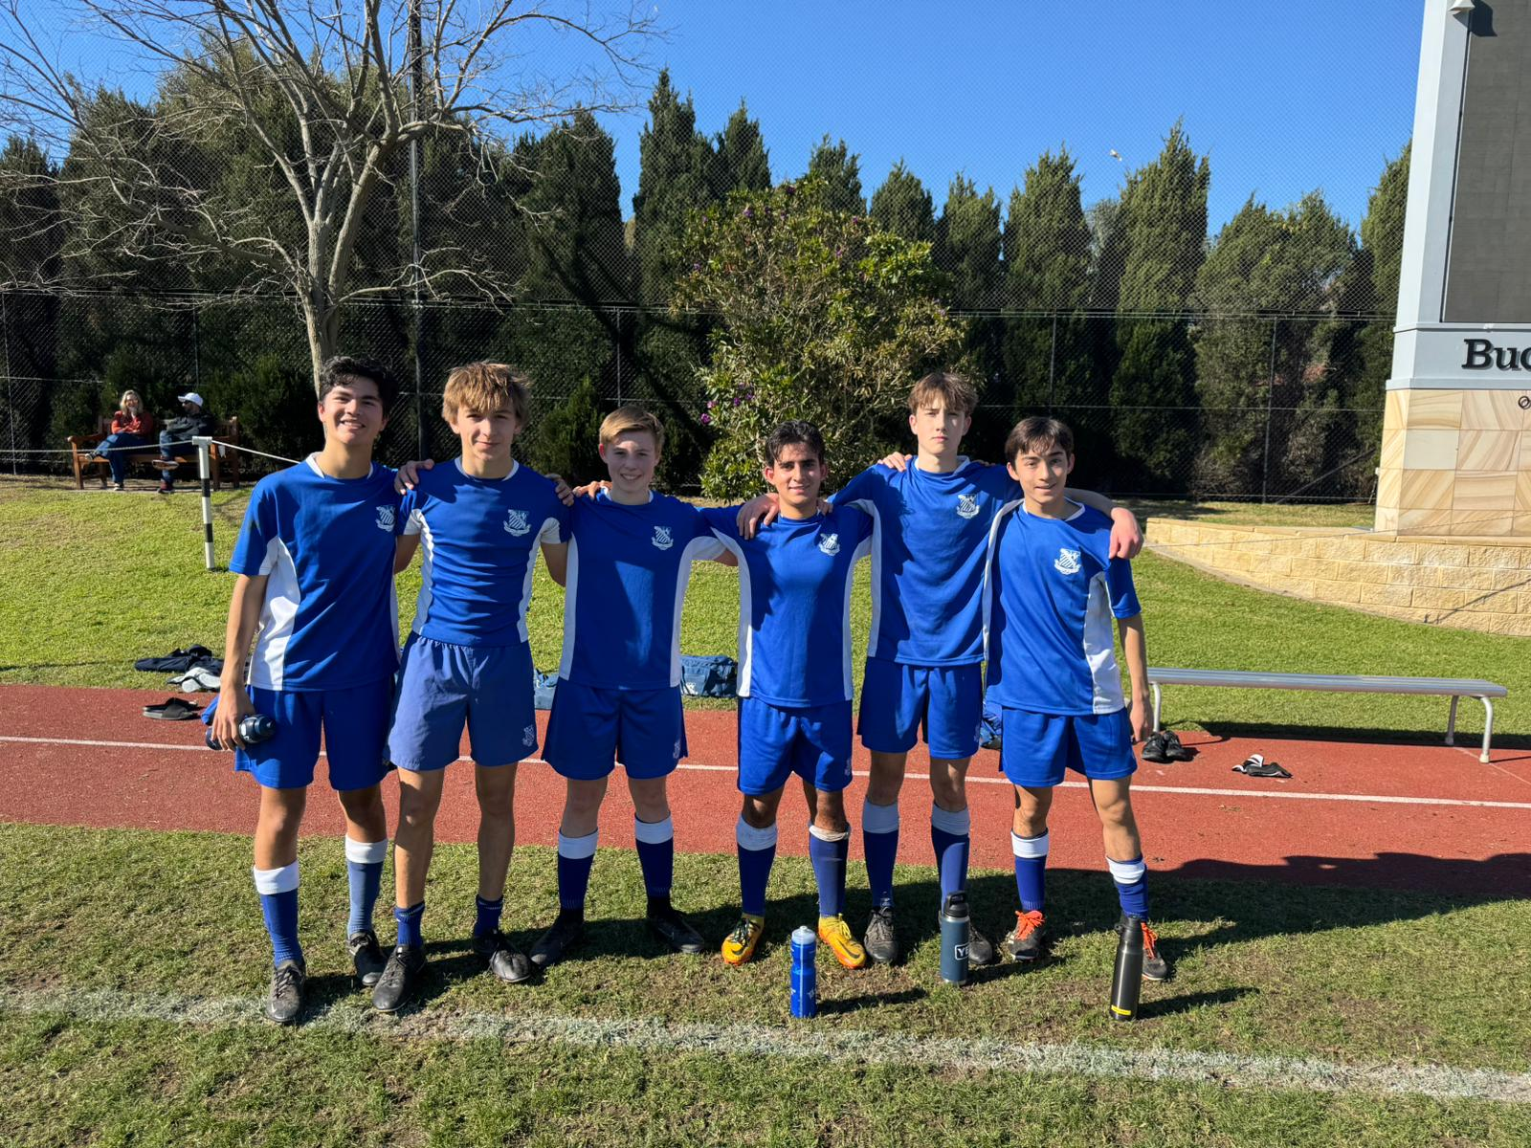
4^{ths} Match Report: Coach Jack Aman
A disappointing result against a very strong Newington side this weekend, going down 6-1. However, a huge credit to the six players on the team who actually showed up, who have been consistently putting in effort both in training and every Saturday, as well as a big thanks to 3 5ths players who came early to help out. It was always going to be a tough game considering we had 9 players, but the boys overall played quite well, with better patterns of play in keeping the ball, and defensively more compact than previous weeks. Hugo made a big penalty save in the first half to keep us in it, as well as scoring our goal in the second half off a corner, that being the only goal Newington's 4th XI has conceded all season. Once again, a big thanks to the same boys for putting in effort all term long, and hopefully more positive results will come in Term 3.

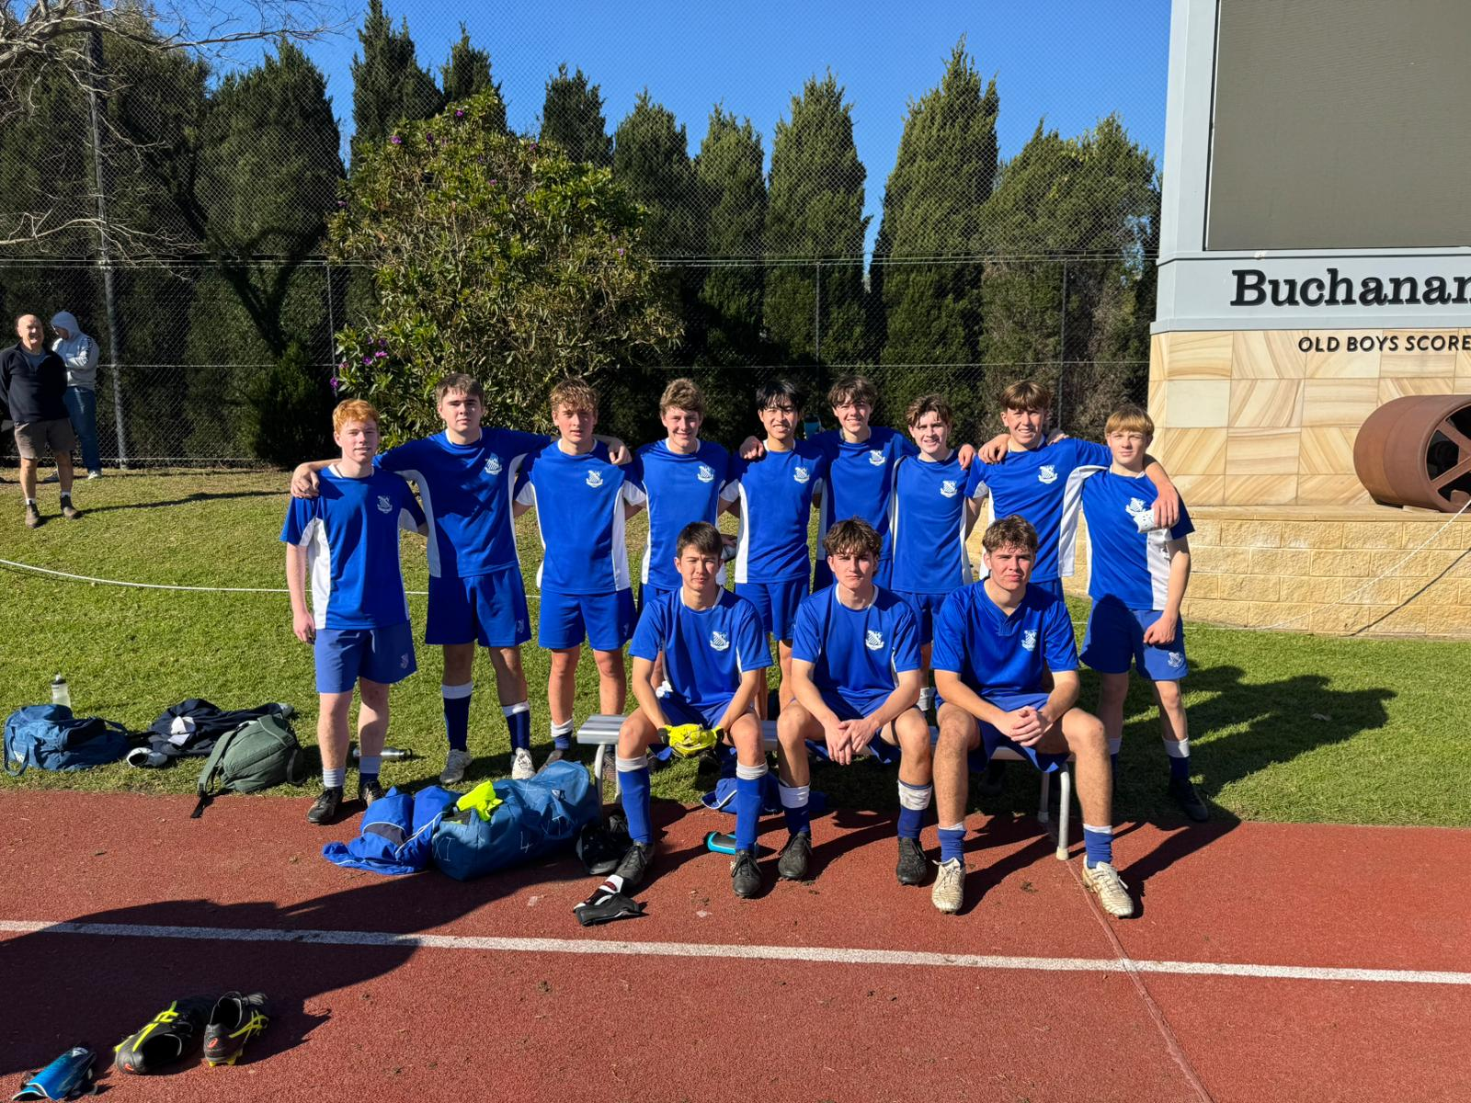
5^{ths} Match Report: Coach Jack Aman
A tough match for the 5ths saw us go down 5-0 against most likely the toughest opponent we will face all season, Newington. Our main issue throughout the game was struggling to get numbers forward, especially in our distribution out of the midfield to our forwards. If we can improve on this going forward, it will make it a lot easier to attack our opponents and put them under pressure. A big shout out to Sam who played in goal all game and made some really big saves, including multiple 1 on 1 chances where he denied the opposition.
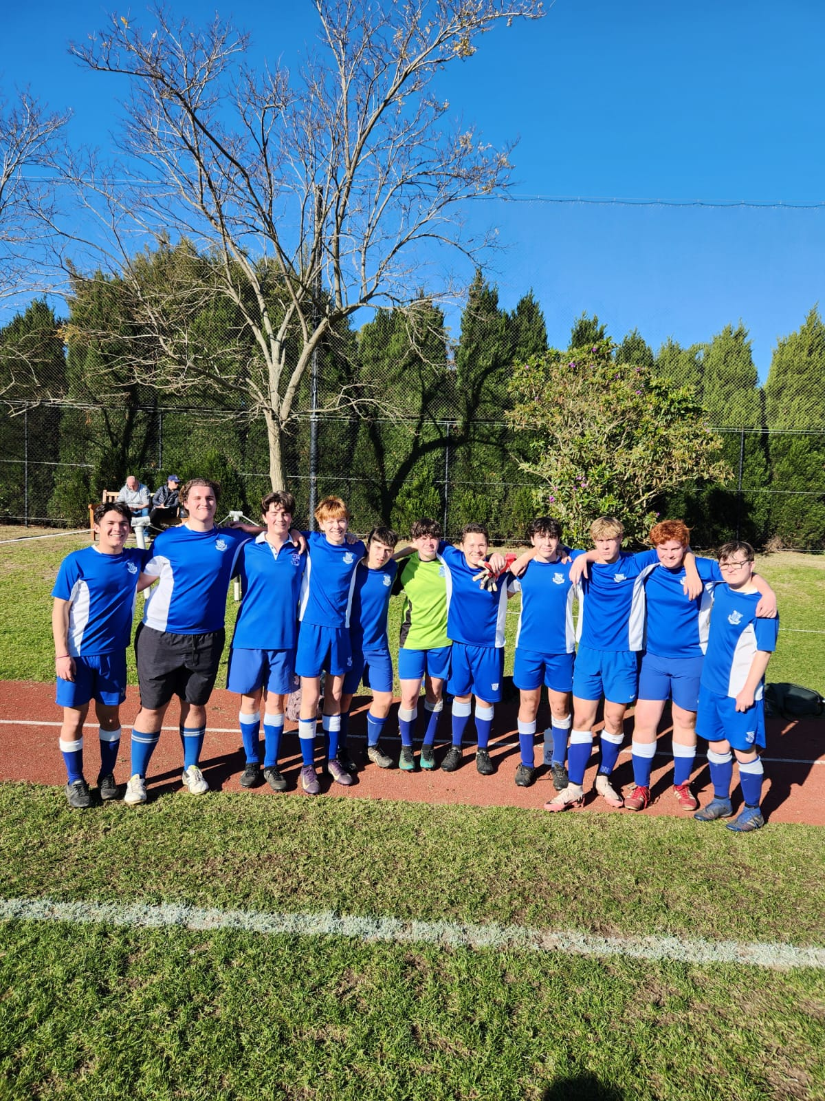
6^{ths} Match Report: Coach Max Jossee
It was a tough and tightly contested match today that could’ve gone either way. The boys put in a great effort from start to finish, showing real determination and creating plenty of chances throughout the game. Unfortunately, despite all the pressure and attacking opportunities, we just couldn’t find the back of the net. The opposition managed to take advantage of one key moment, and that ended up being the difference on the scoreboard. Even though the result didn’t go our way, there were a lot of positives to take away. The work rate, team spirit, and commitment were excellent.
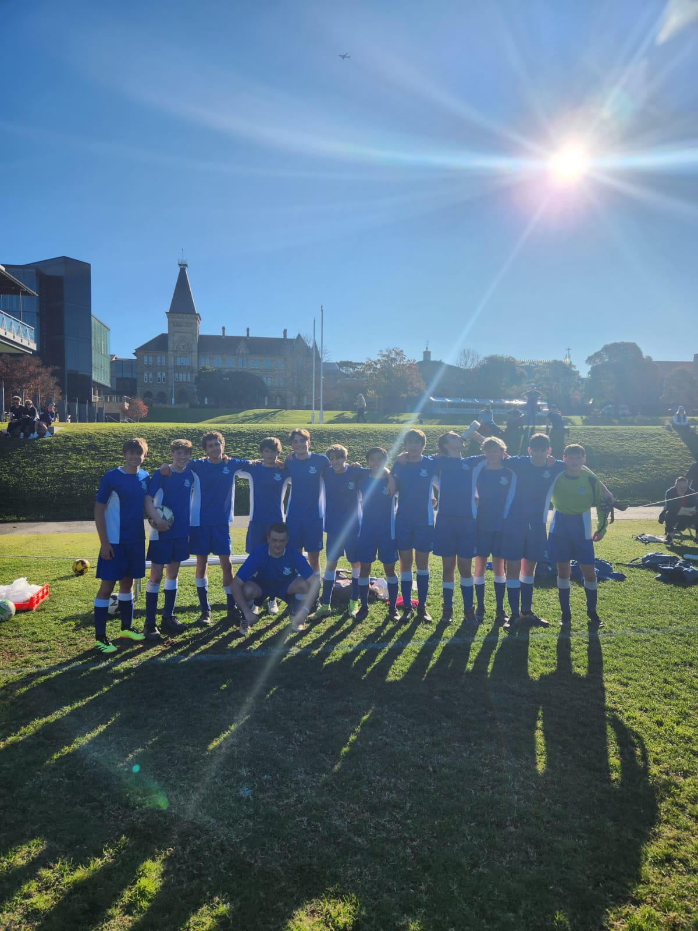
7^{ths} Match Report: Coach Max Jossee
Despite the scoreline, this was a really strong performance from the team. We played with great energy, moved the ball well, and showed real teamwork across the pitch. The boys didn’t back down, even against a side with some very strong attackers. One of the highlights of the game was seeing our goalkeeper come out to play on field in the second half and score a goal! That goal, along with the effort from the rest of the team, showed just how much heart and belief we had throughout the match. The result doesn’t reflect how competitive we were. The boys should be proud of the way they played, especially with the intensity and teamwork they showed. If we’ll keep working and improving our performances like this one, we will heading in the right direction.

